A Web-based Cattle Traceability and marketplace Platform for Kenyan Livestock Producers

Ngure Mercy Nyambura
187915
Githaiga Emmanuel Mundia
189225

ICS 3 Group C

Supervisor Name: Kelvin Ouma

An Informatics and Computer Science Project Submitted to the School of Computing and Engineering Sciences(SCES) in partial fulfilment of the requirements for the award of a Bachelor of Science in Informatics and Computer Sciences

School of Computing and Engineering Science
Strathmore University
Nairobi, Kenya

May 2026

Declaration and Approval
We declare that this work has not been previously submitted and approved for the award of a degree by this or any other University. To the best of our knowledge and belief, the research proposal contains no material previously published or written by another person except where due reference is made in the research proposal itself.

Student Name: Ngure Mercy Nyambura
Admission Number: 187915
Student Signature: Date: .

Student Name: Githaiga Emmanuel Mundia
Admission Number: 189225
Student Signature: Date: .

Supervisor Name: Kelvin Ouma
Supervisor Signature: Date: .

Abstract
The Kenyan Livestock sector, a significant contributor to the national economy and rural livelihoods, is currently hampered by structural informalities, inefficient market systems, and inadequate traceability mechanisms. These systemic challenges lead to substantial economic losses, compromised animal health and food safety, and limited access to lucrative domestic and international markets for livestock producers.
To bridge this gap, this project proposes the design and development of a comprehensive Web-based Cattle Traceability and Marketplace Platform tailored specifically for Kenyan Livestock Producers. Employing Agile methodology, the platform aims to address these critical issues by establishing a robust digital system for unique animal identification and registration, facilitating transparent and efficient livestock marketing, enhancing disease surveillance and control, mitigating livestock theft and ownership disputes, and improving national food safety standards.
Object-Oriented Analysis and Design (OOAD) techniques, including Use Case, Entity Relationship, Class, and Activity Diagrams, will guide the system's modular software architecture. The underlying technology stack will comprise Python (Django) for the backend web framework paired with PostgreSQL relational database system to handle data. The expected outcomes of this platform include a modernized cattle value chain, farm-to-fork food safety assurance, and enhanced national compliance with global trade standards.

Table of Contents
Declaration and Approval 2
Abstract 3
List of Figures 7
List of Abbreviations 8
Chapter 1: Introduction 9
1.1 Background Information 9
1.2 Problem Statement 10
1.3 Objectives of the study 11
1.3.1 General Objective 11
1.3.2 Specific Objectives 11
1.3.3 Research Questions 11
1.4 Justification of the study 12
1.5 Scope 12
1.5.1 Target Stakeholders 12
1.6 Limitations 12
Chapter 2: Literature Review 13
2.1 Introduction 13
2.2 General context 13
2.3 Details on the current state of affairs 13
2.3.1 A global perspective 13
2.3.2 Kenyan Livestock Sector 14
2.3.3 Challenges in the Current State of Affairs 15
2.4 Related Applications 16
2.4.1 NamLITS(Namibia Livestock Identification and Traceability System ) 16
2.4.2 LITS-SA(Livestock Identification and Traceability System-South Africa) 17
2.4.3 NLIS (National Livestock Identification System - Australia) 18
2.4.4 Jaguza Livestock App 19
2.4.5 Gaps in the current Approaches 20
2.5 Technologies Related 21
2.5.1 RFID Technology 21
2.5.2 Blockchain Technology 22
2.6 Data collected during Cattle Traceability 22
2.6.1 Data for Local Market Traceability 22
2.6.2 Data for Export Market Traceability 22
2.7 Conceptual Framework 23
Chapter 3: Methodology 24
3.1 Introduction 24
3.1.1 Object-Oriented Analysis and Design (OOAD) 24
3.2 System Development Life Cycle (SDLC) 24
3.2.1 Planning 24
3.2.2 Requirements 25
3.2.3 Design 25
3.2.4 Development 25
3.2.5 Testing 25
3.2.6 Evaluation 25
3.3 System Analysis 26
3.3.1 Use Case Diagram 26
3.3.2 Sequence Diagram 26
3.3.3 System Sequence Diagram 26
3.3.4 Entity Relationship Diagram(ERD) 27
3.3.5 Class Diagram 27
3.3.6 Activity Diagram 27
3.4 System Design 27
3.4.1 Architectural Design 27
3.4.2 Database Design 27
3.4.3 UI/UX Design 27
3.5 System Development Tools and Techniques 27
3.5.1 Programming Language & Backend Framework 28
3.5.2 Database Management System 28
3.5.3 API Development and Testing 28
3.5.4 Version Control 28
3.6 System Deliverables 28
3.6.1 Animal Registration and Identification Module 28
3.6.2 User Management Module 28
3.6.3 Health and Veterinary Records Module 28
3.6.4 Analytics Module 28
Chapter 4: System Analysis and Design 29
4.1 Introduction 29
4.2 Requirement Analysis 29
4.2.1 Functional Requirements 29
4.2.2 Non-Functional Requirements 32
4.3 System Analysis 33
4.4 System Design 43
Chapter 5: System Implementation and Design 51
5.1 Introduction 51
References 54
Appendix 57

List of Figures

Figure 2.1 Namibia Livestock Identification and Traceability System(NamLITS) ..................18
Figure 2.2 Livestock Identification and Traceability System-South Africa (LITS-SA) ...........19
Figure 2.3 National Livestock Identification System - Australia (NLIS) ..................................20
Figure 2.4 Jaguza Livestock App .................................................................................................21
Figure 2.5 RFID Tags and Reader ...............................................................................................22
Figure 2.6 Conceptual Framework ..............................................................................................24
Figure 3.1 Agile Development Diagram .....................................................................................27
Appendix 1: Gantt Chart ..............................................................................................................33

List of Abbreviations

ANITRAC: Animal Identification and Traceability
ASALS: Arid and Semi-Arid Lands
FAO: Food and Agriculture Organization
GDP: Gross Domestic Product
ICTs: Information and Communication Technologies
ILRI: International Livestock Research Institute
LITS: Livestock Identification and Traceability Systems
LITS-SA: Livestock Identification and Traceability System - South Africa
NLIS: National Livestock Identification System
NamLITS: Namibia Livestock Identification and Traceability System
RFID: Radio Frequency Identification
SPS: Sanitary and Phytosanitary
OOAD: Object-Oriented Analysis and Design
CASE: Computer-Aided Software Engineering
ERD: Entity Relationship Diagram
IPRS: Integrated Population Registration Service
PIC: Property Identification Code
DVS: Directorate of Veterinary Services
CAHW: Community Animal Health Worker
ACID: Atomicity, Consistency, Isolation, and Durability

Chapter 1: Introduction

1.1 Background Information
Livestock farming is one of the most important agricultural activities in Kenya and plays a central role in the country’s economy, food security, rural livelihoods, and cultural identity. Kenya’s livestock is a major component of the national agricultural economy. According to recent economic reporting, earnings from livestock and livestock products increased from Ksh 154 billion in 2022 to Ksh 191 billion in 2023, demonstrating the growing economic value of the subsector (Africa Check, 2024). The Livestock subsector is estimated to contribute approximately 12% to the national Gross Domestic Product (GDP) and 42% of the agricultural GDP (Sirak Bahta, 2023). In Arid and Semi-Arid Lands (ASALs), which host the majority of the national herd, livestock remains the primary source of livelihood.
Animal traceability is described as “the ability to maintain the identification of the animal or animal products, all along the production chain” (Tshepiso Larona Mokgetse, 2026) that is movement, marketing, slaughter, processing, and consumption. It is normally supported by unique animal identification methods such as ear tags, branding, electronic tags, radio frequency identification devices, digital records, and centralized databases (Schmidhuber, 2020). A functional traceability system enables farmers, traders, veterinary officers, processors, regulators, and consumers to access reliable information about the origin, ownership, movement, and health status of livestock. In Kenyan context, such a system is increasingly important because livestock markets are becoming more commercialized, consumers are becoming more concerned about food safety, and export market require strong proof of animal health certification and compliance with sanitary standards.
In Africa, countries like Namibia have a traceability system that complies with global standards, giving them access to global markets (Calitz, 2016). For some countries like Australia, their traceability system is of utmost importance as they need it for their agricultural Industry which focuses mostly on livestock production, and their focus markets are mostly the prestige expensive markets where traceability is a very important requirement (Australian Government, 2016).
The government of Kenya has recognized the importance of animal identification and traceability through the Animal Identification and Traceability Strategy 2020-2030. The strategy identifies animal identification and traceability as a key tool for modernizing and commercializing the livestock sub-sector, improving livestock competitiveness, supporting food safety, enabling disease control, and enhancing access to domestic and international markets (Ministry of Agriculture and Livestock Development, 2026).A related study on livestock identification and traceability systems (LITS )was conducted by the International Livestock Research Institute (ILRI) in selected beef value chains in Uganda and Kenya to determine ways of implementing the systems in the region for improved livestock production and trade (Bernard Bet, 2015).
.

1.2 Problem Statement
Despite its critical role in the economy, Kenya’s livestock sector still operates with a lot of systemic inefficiencies and informalities that undermine its potential. A report done by (Mihindo, Juster, Maina, Manduna, & Hansen-Kuhn, August 2025) shows that Kenya’s livestock sector remains underdeveloped with high levels of informality, which often results in low productivity and limited profitability for livestock farmers. The informal and inefficient Market Systems structure creates significant information asymmetry, hence Kenyan cattle producers remain locked out of premium global markets.
Research Gap: While robust livestock identification and traceability systems(LITS) have been successfully implemented in countries like Namibia (NamLITS Online), South-Africa (LITS-SA), and Australia (NLIS), Kenya has yet to achieve a comprehensive, integrated, and widely adopted national LITS. Existing efforts, such as pilot studied by ILRI (Bernard Bet, 2015), acknowledge the importance of traceability but have not led to a scalable digital platform that effectively addresses the unique challenges of the Kenyan context.
The livestock industry faces several traceability challenges in tracking an animal from conception to consumption. These challenges include a lack of standardization and centralized systems, difficulties in data access and sharing, high costs and complexity in implementing effective systems, resistance to adopting new technologies (Assis & Batista, 2024), and variance in traceability laws and regulations(this changes soon with the rollout of the ANITRAC Bill 2026).

1.3 Objectives of the study
The aim of this project is to enhance the efficiency and transparency of Kenyan cattle value chain through the development of an integrated platform.

1.3.1 General Objective
To design and develop a web-based cattle traceability and marketplace platform for Kenyan Livestock that streamlines livestock management, veterinary certification, ensures food safety, and facilitates accessible and transparent transactions market access.

1.3.2 Specific Objectives
- To develop a cattle identification and registration system that uniquely identifies individual cattle, capturing essential data such as ownership, breed, age, weight, RFID number, and health records. Therefore, each animal will have a verifiable digital identity.
- To develop a database architecture capable of withstanding data-intensive workload and logging real-time data for example, during health interventions, and ownership transfers.
- To implement an efficient marketplace feature that connects cattle sellers directly with buyers, reducing reliance on intermediaries and enabling fair price discovery.
- To integrate a multi-stakeholder authentication feature that allows certified veterinary officers to sign off on health data in the system.

1.3.3 Research Questions
- What are the key requirements for a web-based cattle traceability and marketplace platform that addresses the unique challenges of the Kenyan livestock sector?
- How can a digital platform effectively integrate animal identification, health records, and market transactions to enhance transparency and efficiency in the Kenyan cattle value chain?
- What are the most suitable technologies and architectural design for developing a centralized traceability system in the Kenyan context?
- What type of data is required to be collected from the Kenyan livestock producers?

1.4 Justification of the study
Research has been conducted on Animal traceability system for Kenya in the previous years and turned out to be effective. However, this project addresses concerns raised by researchers on lack of an integrated system which makes it difficult the animal’s lifeline. Moreover, there is emphasis on implementation of electronic tagging that include microchipping and use of RFID tags, which have proven to work successfully in other countries where it has been implemented. The software platform blends seamlessly with this technology because it meets the requirements in terms of data entry and recovery. In addition, the platform directly supports the goal of the ANITRAC 2026 Bill, helping Kenya meet the required global food safety standards (Ministry of Agriculture and Livestock Development, 2026). Other benefits of the technology in cattle traceability are but not limited to: Accountability of farmers and countries, disease control, ease of import/export operations, customer trust, safe and protected data storage – not manual, cattle life cycle history provision and increased productivity.

1.5 Scope
The platform encompasses two primary functional components:
- Cattle Traceability System – This provides functionalities for registration of individual cattle using unique identifiers and recording of health interventions.
- Livestock marketplace – It facilitate connections between sellers and buyers, whereby farmers and sellers can create digital listings for cattle, including photos, detailed description, and health information from the traceability system.

1.5.1 Target Stakeholders
The users and, by extension, beneficiaries of this platform include Cattle farmers & traders, Animal health workers(veterinarians) , meet processors(abattoirs), and customers.

1.6 Limitations
Despite there being more advanced technologies like blockchain and IOT, our technical capacity hinders us to such levels. Another challenge is the electronic identification tools, such as RFID tags and scanners, these gadgets were beyond our reach hence not used for this project, we focused on the functionality of the web-based platform. The platform may be unreliable due to the limited internet connectivity in some regions.

Chapter 2: Literature Review

2.1 Introduction
This chapter presents a review of the foundational knowledge of the livestock sector, both locally and globally, and evaluating the existing digital solutions. The review analyzes various related applications, identifying their functionalities, strengths, and limitations which helped to identify of gaps in the current approaches. Furthermore, it explores key technologies essential for effective cattle traceability, the data requirements for both local and export market, and discuss the technological stacks commonly employed in similar applications. Finally, this chapter outlines the proposed technology stack for this project and present a conceptual framework to guide the platform’s development.

2.2 General context
Cattle Traceability is traceability to track an animal or its products throughout the supply chain, from birth to slaughter and consumption. In this project, the scope encompasses Individual Animal Identification and Marketplace.
- Identification: Associating a unique identifier with an animal to record its lifecycle
- Traceability: Documentation of health, movement & ownership history.
- Marketplace: A digital platform where verified traceability data adds value to the transaction, ensuring buyers purchase healthy and legally owned livestock.

2.3 Details on the current state of affairs

2.3.1 A global perspective
Globally, livestock traceability is driven by food safety and international trade regulations. The need for robust traceability systems extends far beyond national borders, driven by several key factors:
- Food Safety and Public Health
Global trade in Livestock and livestock product requires strict food safety standards to prevent the spread of diseases. Traceability systems are crucial for disease outbreak containment, as demonstrated by various international health crises (FAO, 2020).
- International Trade and Market Access
Countries like Australia (NLIS), Namibia (NamLITS Online), and South Africa (LITS-SA) have successfully implemented national systems that allow them to meet global standards. In contrary, countries lacking such systems face barriers to enter international markets, limiting their export potential
- Agri-tech
Globally, the agricultural sector is undergoing a digital transformation, with the adoption of ICTs to enhance productivity, efficiency, and market access (World Bank, 2024). Digital marketplaces and traceability solutions are at the forefront of this transformation, connecting farmers directly with buyers and providing access to critical market information (World Bank Group, 2025)

2.3.2 Kenyan Livestock Sector
The current state of affairs in the Kenyan livestock sector, particularly concerning cattle, is characterized by a blend of traditional practices and nascent efforts towards modernization. While the sector is a significant economic contributor, its operational framework largely remains informal, presenting both opportunities and substantial challenges.
- Traditional Practices and informal markets:
Historically, cattle trade in Kenya has been dominated by informal channels. Transactions often occur in open-air markets, through brokers, and are based on verbal agreements, handwritten records, and cash payments. This informal structure, while deeply ingrained in cultural practices, leads to significant information asymmetry. Farmers frequently lack access to real-time market prices, demand trends, and verified buyers, making them vulnerable to exploitation by intermediaries who capture a disproportionate share of the profits (Mihindo, Juster, Maina, Manduna, & Hansen-Kuhn, August 2025) (Mdoda & Mdiya, 2022).
- Limited Traceability and Identification:
Despite the government's recognition of the importance of animal identification and traceability through the Animal Identification and Traceability Strategy 2020-2030 (Ministry of Agriculture and Livestock Development, 2026), implementation remains limited. Many cattle transactions lack standardized identification methods, making it difficult to verify animal ownership, track movement history, and ascertain health status. The reliance on manual records, where they exist, is prone to errors, manipulation, and loss, further complicating efforts to establish a verifiable history for individual animals (Mutua, Bukachi, Bett, Estambale, & Nyamongo, May 2017).

- Food Security Concerns:
The absence of a transparent ‘farm-to-fork’ traceability system raises concerns about food safety, particularly for consumers and potential export markets that demand stringent Sanitary and Phytosanitary (SPS) standards.
- Regulatory Framework in Transition:
The Kenyan government is actively working to formalize and modernize the sector. The ANITRAC Bill 2026 signifies a strong policy push towards mandating electronic identification and establishing a national traceability system. However, the current state is one of transition, where the regulatory framework is evolving, and the necessary infrastructure and widespread adoption mechanisms are still being developed. This transition period presents a critical window for the introduction of innovative solutions that can align with and support these governmental efforts.

2.3.3 Challenges in the Current State of Affairs
The current state of the Kenyan livestock sector is faced with numerous challenges that impede its growth, efficiency, and ability to meet global market standards.
- Market Informality and inefficiency:
The scarcity of formalized trading platforms restricts farmers’ reach to a broader market, both domestically and internationally. Most cattle trade happens in physical markets with no digital record of the animal’s health history. Small-scale farmers and pastoralists often lack access to crucial market information, as a result, the intermediaries get to exploit the situation. This leads to suboptimal prices for producers and reduced profitability (Mihindo, Juster, Maina, Manduna, & Hansen-Kuhn, August 2025).
- Inadequate Traceability and Identification Systems:
Without unique identifiers and a centralized database, it is challenging to confirm the true ownership or origin of an animal. This fuels theft and makes disputes resolution complex (Mutua, Bukachi, Bett, Estambale, & Nyamongo, May 2017). In relation to disease control, the inability to track animal movements effectively hinders quick response to disease outbreaks, posing risk to animal health, public health as a result of zoonotic diseases and the overall economic stability of the sector.
- Technological Barriers:
Many smallholder farmers and pastoralists, particularly in rural and remote areas, have low levels of digital literacy, making challenging for them to effectively use complex digital platforms. Internet connectivity, especially in remote livestock-producing regions, is often unreliable or non-existent, limiting access to web-based or data-intensive applications. Another issue is the upfront cost of the electronic identification tools (for example., RFID tags, scanners) which can constrain the farmers.

2.4 Related Applications
Several platforms and applications have emerged to address various aspects of livestock management, traceability, and marketing, particularly in Africa.

2.4.1 NamLITS(Namibia Livestock Identification and Traceability System )
NamLITs was introduced by Namibia in 2004 to ensure the identification and traceability of livestock. It was primarily developed to meet the requirements of European Union and other international markets, allowing Namibia to remain a significant meat exporter (Paskin)
NamLITS operates as a centralized database that records the entire life history of an animal. It mandates the use of unique, tamper-proof ear tags for all cattle. The system tracks animal births, movements between farms, health interventions, and slaughter. Producers can perform various functions directly on the NamLITS online platform, including registering animals, recording movements, and accessing market information. The system's success is attributed to its integration with veterinary services and its ability to provide verifiable data for export certification, ensuring compliance with international Sanitary and Phytosanitary (SPS) standards.
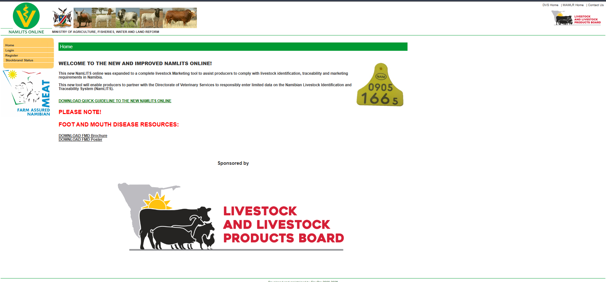
Figure 2.1 Namibia Livestock Identification and Traceability System(NamLITS)

2.4.2 LITS-SA(Livestock Identification and Traceability System-South Africa)
LITS-SA is a farmer-led initiative in South Africa aimed at establishing a practical, privacy-first livestock identification and traceability system. It focuses on enhancing biosecurity, improving market access, and providing reliable movement records for the red meat industry (LITS-SA).
LITS-SA emphasizes a decentralized approach where data is managed by producers and industry bodies. It utilizes unique identifiers and digital platforms to record animal movements and health status. The system is designed to be user-friendly and adaptable to various farming scales. By providing a verifiable history of animal movements, LITS-SA aims to strengthen consumer confidence and facilitate access to both domestic and international markets.

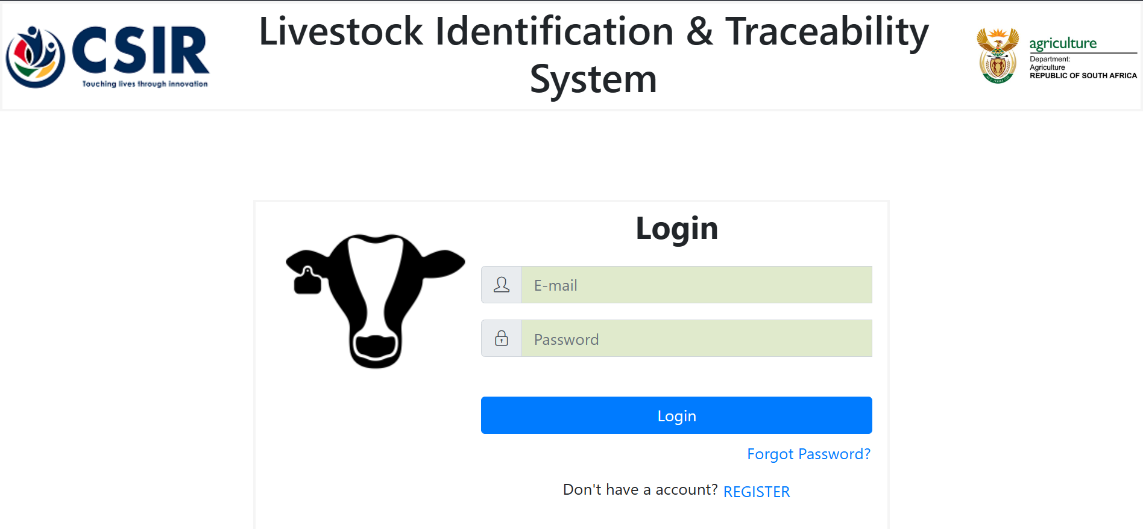
Figure 2.2 Livestock Identification and Traceability System-South Africa (LITS-SA)

2.4.3 NLIS (National Livestock Identification System - Australia)
NLIS is one of the world’s most advanced systems for the Identification and traceability of cattle, sheep, and goats. It is a mandatory system designed to protect Australia’s livestock industries and ensure access to global markets (NLIS).
NLIS uses a combination of permanent identifiers (typically RFID ear tags or ruminal boluses), movement documents (National Vendor Declarations), and a centralized national database. Every time an animal moves to a new property, the movement must be recorded in the NLIS database. This allows for rapid and accurate tracing of an animal's entire residency history, which is crucial for disease control and food safety. The system provides a high level of transparency and integrity, enabling Australia to meet the most rigorous international trade requirements.
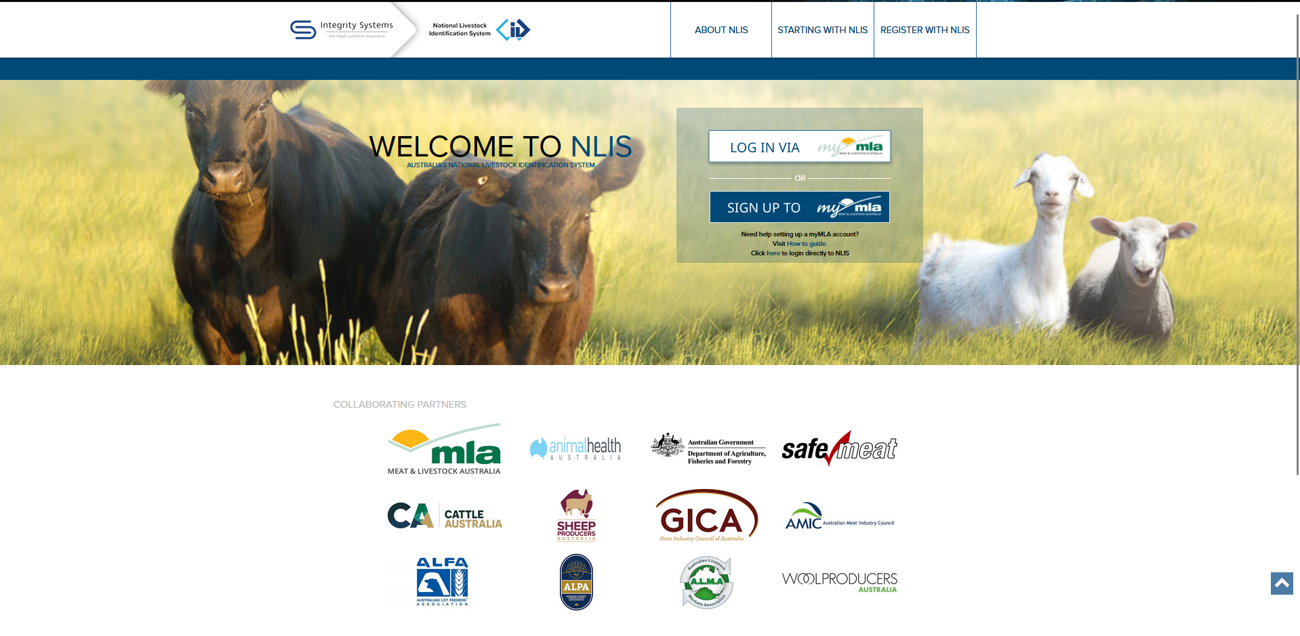
Figure 2.3 National Livestock Identification System - Australia (NLIS)

2.4.4 Jaguza Livestock App
Jaguza is an Agri-tech solution developed in Uganda, aiming to transform livestock farming through real-time animal tracking, health monitoring, and farm record management. It leverages IoT sensors, drones, and AI to provide comprehensive data to farmers, enabling better decision-making and improved productivity (Jaguza Farm).
Jaguza operates as a comprehensive farm management platform. Farmers can register their animals, track their health status, breeding cycles, and milk production. It provides alerts for potential health issues and offers insights into herd performance. A key feature is its marketplace, which allows farmers to list their livestock for sale, connecting them with potential buyers.
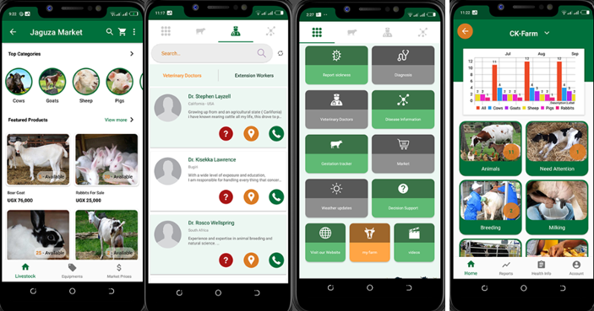
Figure 2.4 Jaguza Livestock App

2.4.5 Gaps in the current Approaches
The existing applications such as Jaguza Livestock App, NamLITS, LITS-SA, and NLIS demonstrates that solutions for livestock management, traceability, and market access already exist globally and regionally. Despite the success of these systems elsewhere, Kenya has not yet fully implemented a functional, unified digital traceability system that is accessible to the average smallholder farmer.
However, there are applications in Kenya like iCow which is a mobile-based platform designed to improve smallholder dairy farmer productivity and profitability. It initially focused on providing farmers with critical information via SMS, such as gestation calendars, optimal breeding times, and veterinary advice. It has evolved to include a marketplace (iCow Soko) that allow farmers to buy and sell livestock, connecting them directly and reducing reliance on intermediaries. (iCow).
The specific reason for the limited adoption and integration of such systems in Kenya, despite their proven benefits in other countries, constitutes a critical research gap. This project aims to bridge this gap by designing a platform specifically adapted to Kenya’s informal market structures, diverse farming practices, and varying levels of technological literacy, thereby facilitating implementation and widespread acceptance.

2.5 Technologies Related
This section details the primary technologies relevant to this study.

2.5.1 RFID Technology
In livestock management, RFID tags are small electronic devices attached to animals, typically as ear tags or ruminal boluses, that contain electronically stored information. This information can be read by an RFID reader or scanners without direct line-of-sight, making it highly efficient for tracking large numbers of animals.
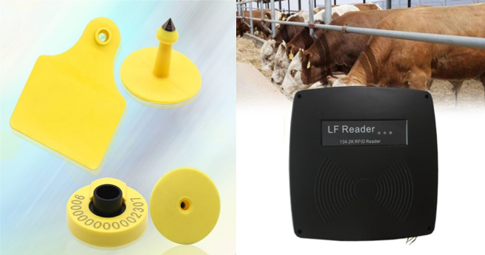
Figure 2.5 RFID Tags and Reader

When an RFID tag passes within the range of an RFID reader, the reader's antenna picks up the tag's unique identification number. This data is then transmitted to a central database or a connected device (like a smartphone or computer) for processing, recording, and analysis. This automated data capture significantly reduces manual errors and improves the speed and accuracy of identification (ID Tech Solutions Private Limited).

2.5.2 Blockchain Technology
Block chain is a decentralized, distributed ledger technology that records transactions across many computers. Each block in the chain contains a timestamped batch of valid transactions, and once recorded, data in a block cannot be altered retroactively without alteration of all subsequent blocks and a consensus of the network.
While not our primary focus in this project because of its complexity, blockchain offers significant potential for enhancing immutability of traceability data. Each event in an animal's life (birth, vaccination, movement, sale) could be recorded as a transaction on a blockchain. This would create an unchangeable, transparent record of an animal's history, significantly boosting trust, especially for international buyers concerned about fraud or data manipulation. It could provide an additional layer of verification for health certificates and ownership transfers, making the entire supply chain more resilient and credible (Mokgetse, 2026).

2.6 Data collected during Cattle Traceability
The effectiveness of any cattle traceability system depends on the data collected throughout an animal’s life cycle. The type of data required depend on the target market, whether local or international.

2.6.1 Data for Local Market Traceability
The primary objective of traceability for local markets often revolves around ownership verification, basic health management, and market efficiency. The data collected typically include A unique identifier for each animal, ownership information, birth information, basic health records, and transaction records.

2.6.2 Data for Export Market Traceability
Export markets impose much stricter requirements due to concerns about food safety, animal health, and consumer protection. This includes all data required for local markets, plus additional critical information such as full health history, farm management practices, and export documentation.

2.7 Conceptual Framework
The process begins with the input phase, where the Farmer gets to register in the system by filling farmers details, farm location and the credentials are recorded in the database server. The radio frequency tower reads the animal’s data via the RFID tags and the information is capture and recorded in the database server. This ensures that every animal is digitally tethered to its owner and farm location from the point of registration.
The cloud computer performs core logics of the system such as authentication of the farmer’s credentials during registration, it acts as the traceability engine by synchronizing and updating the data record in real-time, it also updated the current marketplace status. The system administrator can modify data in the system since they have full access to the system.
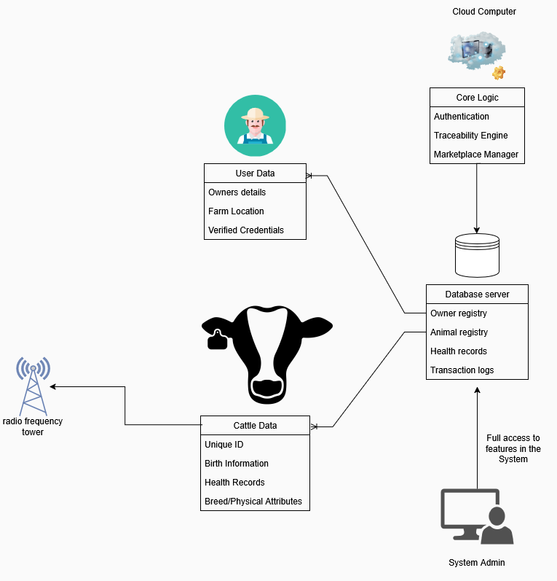
Figure 2.6 Conceptual Framework

Chapter 3: Methodology

3.1 Introduction
This Chapter outlines the research methodology and the system development approach that will be employed in the design and implementation of the proposed Web-based Cattle Traceability and Marketplace Platform for Kenyan Livestock Producers. It will include the System Development Lifecycle model, Object-Oriented Analysis and Design(OOAD) techniques, system analysis, system design, and data collection methods.
This project adopts the Design Science Research (DSR) framework. It focuses on the development and performance of artifacts (such as web applications, algorithms, and human-computer interfaces) created to solve identified practical problems (Brocke, Hevner, & Maedche, 2020).

3.1.1 Object-Oriented Analysis and Design (OOAD)
The Object-Oriented Analysis and Design (OOAD) techniques will be used to model the system from different perspectives, facilitating a clear understanding of its structure, behavior, and interactions. This approach promotes modularity, reusability, and maintainability of the software system (geeksforgeeks, 2026).

3.2 System Development Life Cycle (SDLC)
The Agile Scrum methodology will be adopted for the system development lifecycle. Agile scrum is an iterative and incremental framework that emphasizes flexibility, collaboration, and rapid delivery of functional software (Schwaber & Sutherland, 2017). This approach is well-suited for projects with evolving requirements and a need for continuous feedback from stakeholders, which is typical in agricultural technology development.
The key phases of the Agile Scrum methodology for this project will include:

3.2.1 Planning
This step involves defining the project vision(high-level goal), defining the tasks, establishing priorities, organizing the work, estimating resources and timelines.

3.2.2 Requirements
This phase involves identifying system requirements and user requirements by engaging with the stakeholders (farmers, traders, and veterinarians) for example through interviews and questionnaires.

3.2.3 Design
Once the requirements are clear, they are analyzed and the design for the system architecture is then developed to define how different components of the system will interact hence providing a clear structure for development.

3.2.4 Development
The features designed in the system architecture are now implemented. This is where code is written based on the structural design.

3.2.5 Testing
After implementation, unit, integration, system, and user acceptance testing is conducted to ensure quality and functionality of the developed code throughout the development process.

3.2.6 Evaluation
The final product is reviewed regularly to assess the progress in comparison to the high-level goals and requirements of the project to identify areas of improvement before deployment.

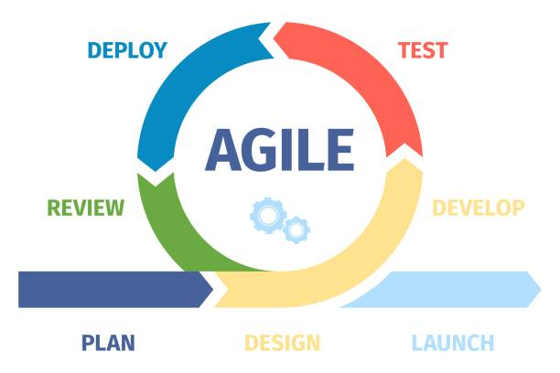
Figure 3.1 Agile Development Diagram

3.3 System Analysis
This will involve a detailed examination of the functional and non-functional requirements identified during the requirements gathering phase. This includes:
- Functional Requirements
Defining what the system must do, such as animal registration, health record management, movement tracking, marketplace functionalities (listing, searching, offering, transacting), user authentication, and reporting.
- Non-Functional Requirements
Specifying quality attributes like performance (response time, scalability), security (data encryption, access control), usability (intuitive interface), reliability (uptime, error handling), and maintainability.
- Stakeholder Analysis
Identifying all individuals and groups affected by the system and understanding their needs, expectations, and potential impact on the project.

3.3.1 Use Case Diagram
The Use Case Diagram illustrates the functional requirements of the system by showing how different users interact with the system to achieve specific goals providing a high-level view of the system functionality.

3.3.2 Sequence Diagram
A sequence Diagram depicts the interactions between objects arranges in a time-ordered sequence, showing the calls between different processes or objects in the system.

3.3.3 System Sequence Diagram
A System Sequence Diagram (SSD) shows the interaction between external users and the system as a whole, focusing on the sequence of events at the system boundary.

3.3.4 Entity Relationship Diagram(ERD)
The Entity Relationship Diagram(ERD) visually represents the relationships between different entities within the database. It defines the structure of the database, including entities, their attributes, and the relationships between them.

3.3.5 Class Diagram
The class Diagram illustrates the static structure of the system, showing the classes, their attributes, operations(methods), and the relationships between them. It provides a blueprint for the system's object-oriented design.

3.3.6 Activity Diagram
An Activity Diagram models the flow of control of an activity, showing the sequence of actions, decisions, and parallel processes. It is useful for visualizing business processes and workflows within the system.

3.4 System Design
System design will translate the analyzed requirements into a detailed architecture blueprint for the platform.

3.4.1 Architectural Design
Architectural Design defines the overall structure of the system, including its components, their responsibilities, and how they interact.

3.4.2 Database Design
Database Design involves Creating the logical and physical database schema based on the ERD, including tables, relationships, data types, and indexing strategies to ensure data integrity, efficiency, and scalability. (Sommerville, 2011).

3.4.3 UI/UX Design
User Interface(UI) / User Experience(UX) Design involves developing wireframes, mockups, and prototypes to visualize the platform’s interface and ensure an intuitive and user-friendly experience for all stakeholders.

3.5 System Development Tools and Techniques
This phase outlines the Computer-Aided Software Engineering (CASE) tools that will be used to support the development process of the system.

3.5.1 Programming Language & Backend Framework
Python(For backend logic and data processing) and Django(Python-based web framework). This stack provides for rapid development built-in user authentication modules, security features and utilizes the Object-Relational Mapping (ORM) for Databases Structure.

3.5.2 Database Management System
PostgreSQL(relational database) for its reliability, advanced features, and strong support for complex data types and large datasets.

3.5.3 API Development and Testing
Django REST Framework for building RESTful APIs, and Postman for testing API endpoints.

3.5.4 Version Control
Git and GitHub will be used for collaborative development, code management, and tracking changes. This enhances teamwork and productivity.

3.6 System Deliverables
Upon completion, the proposed system will consist of several integrated modules, including:

3.6.1 Animal Registration and Identification Module
This module enables the digital registration of cattle, capturing unique identifiers (RFID tag IDs), breed, age, gender, and initial ownership details.

3.6.2 User Management Module
User Management handles user registration, authentication, profile management, and role-based access control for farmers, buyers, veterinary officers, and administrators.

3.6.3 Health and Veterinary Records Module
This module allows for the recording and tracking of animal health history, vaccinations, treatments, and veterinary certifications.

3.6.4 Analytics Module
This module provides data visualization analysis.

Chapter 4: System Analysis and Design

4.1 Introduction
This Chapter presents the complete system analysis and design of the requirements of the platform and outlines its architectural and design specifications. The platform is designed to digitize the identification, movement, health monitoring, and commercial trading of livestock in Kenya, addressing the operational gaps of smallholder farmers, pastoral communities, livestock traders, veterinary officers, county directorate of veterinary services (DVS), and abattoir operators.
The chapter is structured into three major sections. The first covers Requirement Analysis which captures the functional and non-functional specifications The second section covers System Analysis, which translates those requirements into formal UML models including use-case, sequence, system sequence, entity relationship, class, and activity diagrams. The third section covers System Design, which details the database schema, application wireframes, and overall system architecture that will guide technical implementation.

4.2 Requirement Analysis
Requirement analysis is a critical phase that involves identifying, documenting, and validating the needs of the stakeholders and the system. For the Kenya Livestock Traceability and Marketplace Platform, requirements were derived through a multi-source process: comparative study of three operational national livestock traceability systems (Australia NLIS, Namibia NamLITS, and South Africa LITS-SA), contextual analysis of the Kenyan livestock sector, and identification of the six primary stakeholder categories whose workflows the system must support.
Requirements are classified into two categories: functional requirements (what the system must do) and non-functional requirements (how well the system must do it).

4.2.1 Functional Requirements
Functional requirements define the specific actions or services that the system must perform. The functional requirements below are grouped by the primary actor they serve:

Farmer/Owner
- The system shall allow a farmer to register an account using their national ID number and mobile phone number, with identity verification against the Integrated Population Registration Service (IPRS).
- The system shall allow a registered farmer to register a holding (property) by providing county, sub-county, ward, and GPS coordinates, generating a unique Holding ID (PIC).
- The system shall allow a farmer to register individual animals by scanning or manually entering an RFID or ear tag number, and recording species, sex, age class, breed, estimated live weight, and photographs.
- The system shall allow a farmer to create a marketplace listing for one or more registered animals, specifying asking price, sale type, and delivery arrangement.
- The system shall enforce that only animals with status ACTIVE may be listed for sale; animals with status STOLEN, DEAD, or SLAUGHTERED shall be blocked from listing.
- The system shall allow a farmer to accept or decline an offer received from a buyer.
- The system shall allow a farmer to report an animal as stolen, immediately setting its status to STOLEN and blocking all future sale attempts.
- The system shall deliver carcass feedback (grade, weight, and quality information) to the farmer via SMS when their animal has been processed at an abattoir.

Trader/Buyer
- The system shall allow a registered trader or buyer to browse marketplace listings, filtering by species, county, breed, price range, and age class.
- The system shall allow a buyer to view the full animal profile of a listed animal, including its complete health event history, ownership chain, and vaccination credibility level.
- The system shall allow a buyer to make an offer on a listing and receive a notification when the seller responds.

Animal Health Worker(Vet/CAHW)
- The system shall allow a registered animal health worker to record a vaccination event against a specific animal, capturing disease or vaccine name, date, and recorder identity.
- The system shall allow a registered animal health worker to record a disease event or clinical observation against a specific animal.
- The system shall assign a credibility level of VET_VERIFIED to health events recorded by a verified county veterinarian (DVS number confirmed), and a level of OBSERVATION to events recorded by a CAHW.
- The system shall allow an animal health worker to escalate a suspected disease to the assigned county DVS officer for review.
- The system shall automatically notify the county DVS via SMS when a verified veterinarian records a notifiable disease.
- The system shall allow a verified veterinarian to certify an animal death, setting its status to DEAD and permanently closing its lifecycle record.
- The system shall allow any registered health worker to view the complete health event history of any animal in their assigned zone.

County DVS Officer
- The system shall allow a county DVS officer to approve or reject inter-county movement permits for animals crossing county boundaries.
- The system shall automatically create a movement record with status PENDING_PERMIT for any sale transaction where the source holding and destination holding are in different counties.
- The system shall allow a county DVS officer to place a movement restriction on a specific holding or PIC, which will automatically block all future movement permit applications from that holding.
- The system shall allow a county DVS officer to run a disease trace report that returns all animals present at a specified holding within a configurable date range.
- The system shall allow a county DVS officer to view a county-level livestock census report showing active animal counts by species.
- The system shall allow a county DVS officer to register and verify CAHW accounts within their assigned county.

Abattoir/Processor
- The system shall allow an abattoir operator to scan incoming animal tags and verify that a valid movement record exists before slaughter is permitted.
- The system shall block slaughter of any animal with status STOLEN, DEAD, or SLAUGHTERED.
- The system shall allow an abattoir operator to record a kill by submitting the slaughter date, chain number, and last holding PIC.
- The system shall atomically update the animal status to SLAUGHTERED and create a SlaughterRecord when a kill is recorded.
- The system shall allow an abattoir operator to attach carcass feedback to a slaughter record.
- The system shall allow an abattoir operator to generate a batch number that groups multiple animals slaughtered on the same day into a single traceable product lot.

4.2.2 Non-Functional Requirements
Non-functional requirements specify the quality attributes of the system and the constraints under which it must operate. These include:

Data privacy
All data transmitted shall be encrypted, for example, only certified veterinary officers can sign off on health records, buyers can't see farmers' national IDs and only registered farmers can create animal listings.

Usability
The user interface shall be designed to accommodate users with varying levels of digital literacy, including rural livestock farmers. Core workflows — such as registering an animal, recording a health event, or creating a marketplace listing — shall be completable within 5 steps or fewer.

Reliability
Focused on the consequences of failure in a livestock transaction context whereby a dropped health record could clear an uncertified animal for slaughter, the dual write of animal ownership update and movement record creation shall be implemented as a single atomic database transaction.

Scalability
The system architecture (Django backend + PostgreSQL) shall be designed to scale horizontally to accommodate growth in registered animals and users as adoption increases nationally, particularly in anticipation of compliance with the ANITRAC Bill 2026.

Localization
The system shall support English as the primary interface language. The system shall store all monetary values in Kenyan Shillings (KES) and all weight values in kilograms (kg).

4.3 System Analysis
System analysis involves a detailed examination of the functional and non-functional requirements to understand the system's operational context and identify potential challenges and opportunities.
The analysis phase for the platform has six UML diagrams. Together they provide complete coverage of, who interacts with the system and why (use-case), what objects exist and how they relate (class), what data persists and how it is structured (ERD), what sequence of messages achieves a use case (sequence and system sequence), and how control flows through the primary business scenario (activity).

4.3.1 Use-Case Diagram
A use-case diagram is a behavioral UML model that identifies the actors who interact with a system, the goals those actors pursue (use cases), and the associations between them. The use-case diagram defines the functional scope of the system from an external perspective, without prescribing how the system achieves any particular goal.
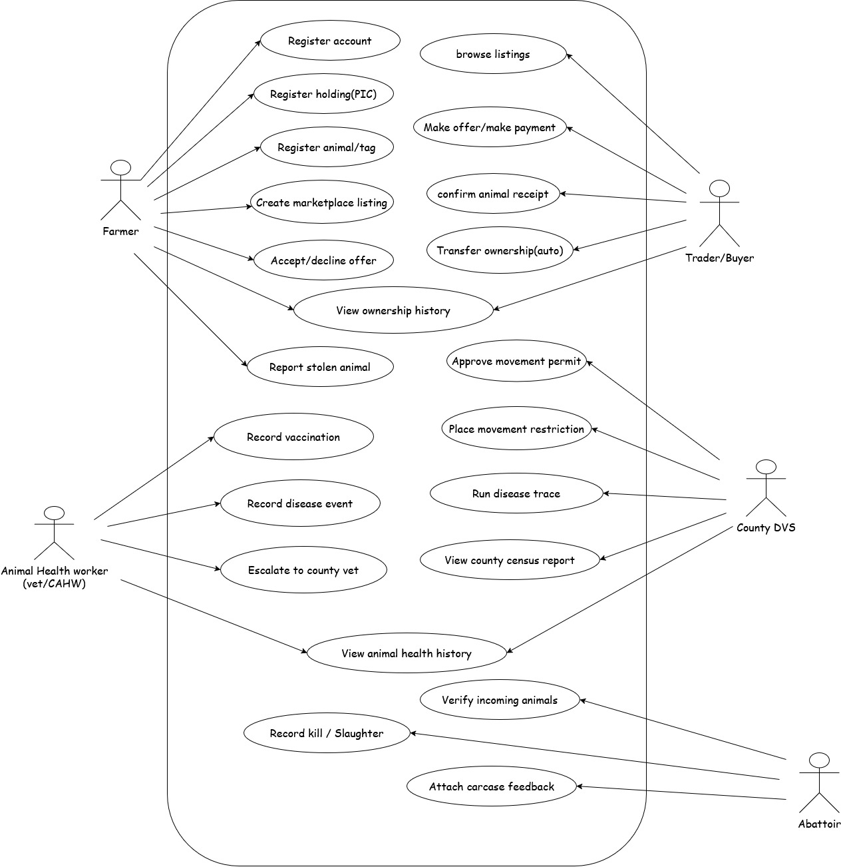
Figure 2: Use-Case Diagram

4.3.2 Sequence Diagram
A Sequence Diagram illustrates the interactions between objects or components in a time-ordered sequence for a specific use case. It shows the calls between different processes or objects in the system, highlighting the flow of control and messages exchanged. Below is a textual description of a typical sequence for 'Listing an Animal for Sale'.
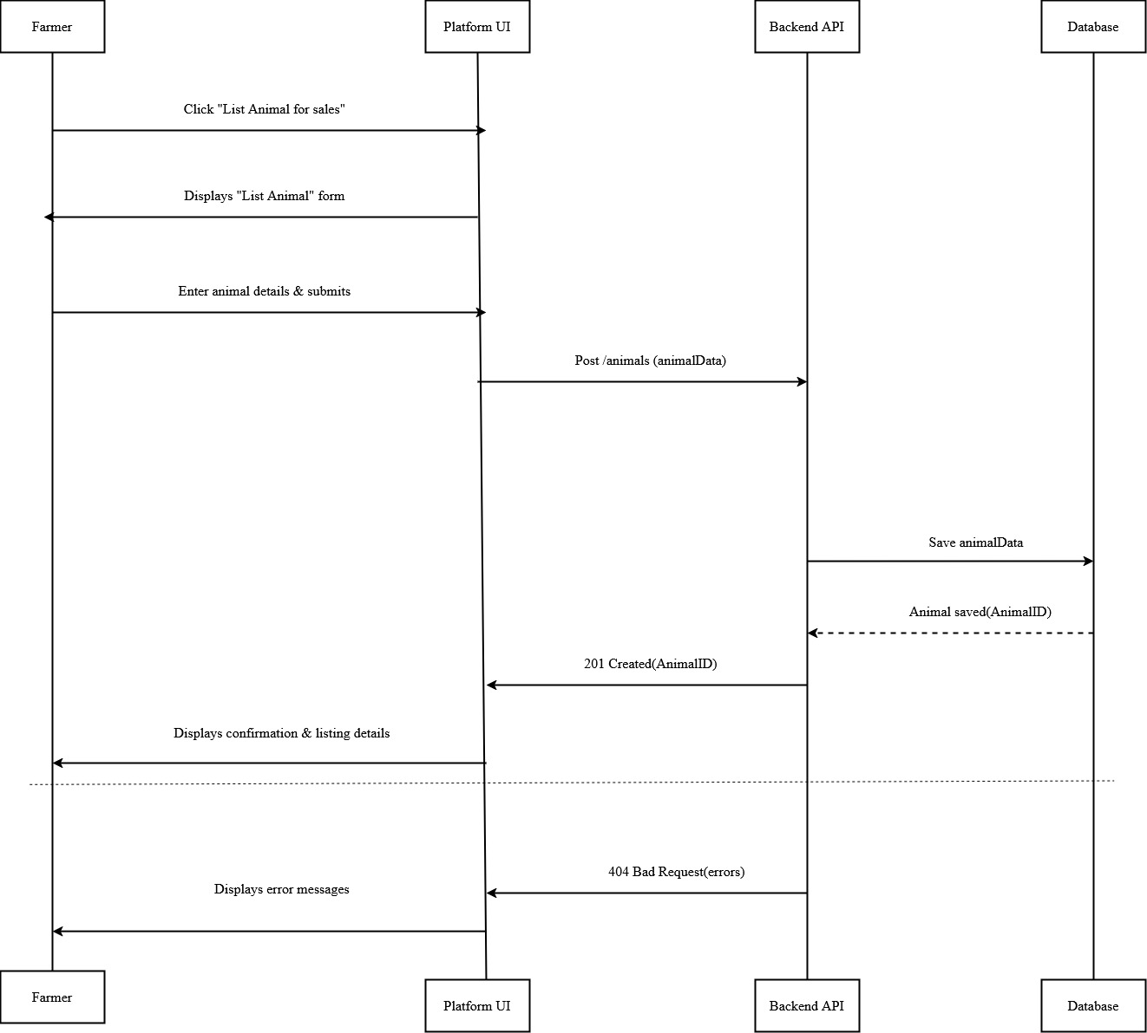
Figure 3: Sequence Diagram

4.3.3 System Sequence Diagram
A system sequence diagram (SSD) is a form of sequence diagram used during requirements and analysis in which the entire system is treated as a single black box. Only external actors and their interactions with the system boundary are visible; no internal classes, service methods, or domain objects are shown. The SSD is the appropriate diagram for agreeing with stakeholders on the system's external contract: what inputs it accepts and what responses it produces. Below is a textual description of an SSD for a user listing an animal for sale.
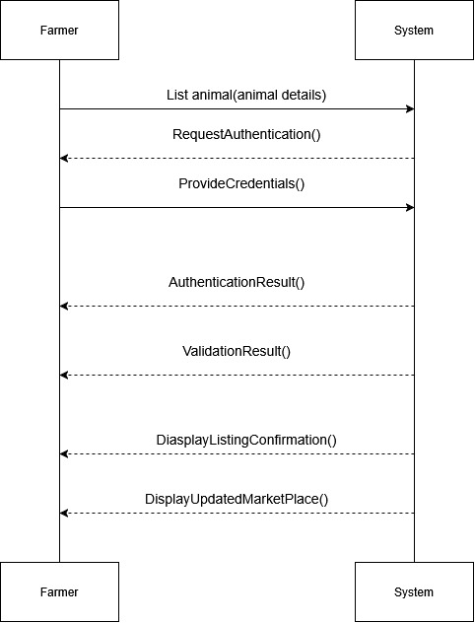
Figure 4: System Sequence Diagram

4.3.4 Entity Relationship Diagram
An entity relationship diagram (ERD) is a structural model that defines the data entities a system must persist, the attributes of each entity, and the relationships and cardinalities between them. The ERD serves as the primary input to the physical database schema and is the authoritative reference for all foreign key relationships in the system.

The Kenya Livestock Platform ERD contains nine entities: Farmer/Owner, Holding/Property, Animal, Movement Record, Health Events, Transaction, Slaughter Records, Animal Health Worker, and Abattoir. The Animal entity is the central hub of the data model, holding foreign key references to the Owner (current_owner_ID), Holding (current_holding_ID and birth_holding_ID), and participating in one-to-many relationships with Movement Record, Health Events, and Transaction, and a one-to-one relationship with Slaughter Records.

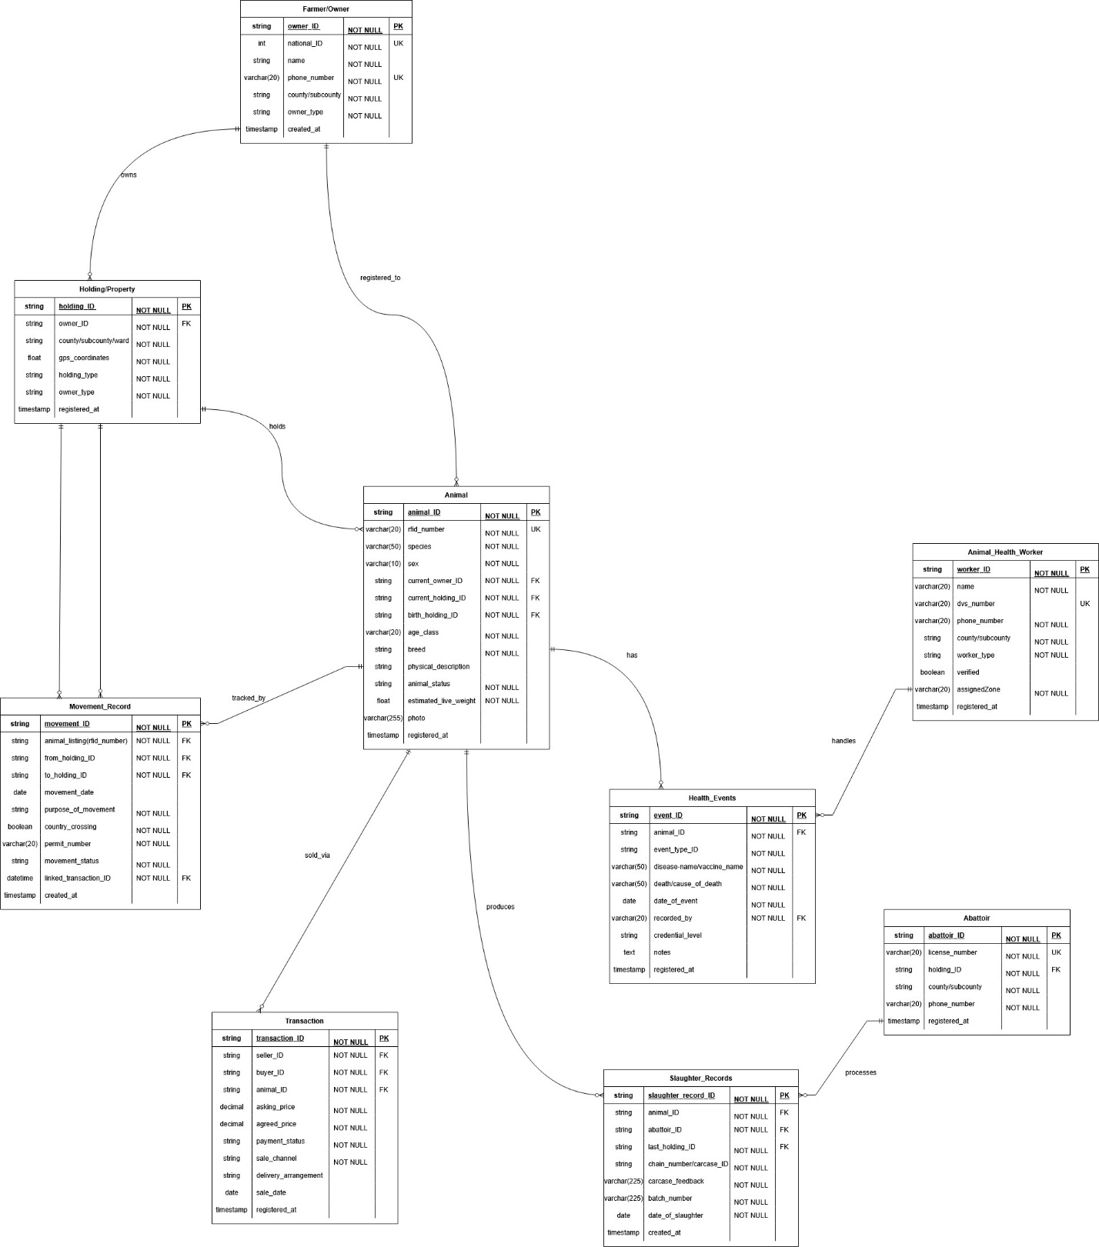
Figure 5: Entity Relation Diagram

4.3.5 Class Diagram
The Class Diagram provides a static view of the system's object-oriented structure, showing classes, their attributes, operations, and the relationships (association, inheritance, aggregation, composition) between them. It is fundamental for object-oriented programming.
Inheritance: The AnimalHealthWorker class is subclassed into two specializations — Veterinarian (holding a DVS registration number and county assignment) and CAHW (Community Animal Health Worker). This inheritance hierarchy enables polymorphic dispatch of the recordHealthEvent() operation, where the concrete subclass determines the credibility level (VET_VERIFIED vs. OBSERVATION) assigned to the resulting HealthEvent. Similarly, the Transaction class may be extended to distinguish SaleTransaction from TransferTransaction, sharing common attributes (transaction_date, amount, status) while overriding the finalizeTransfer() method.
Multiplicity: The diagram enforces precise cardinality constraints across all associations. An Owner may register zero or more Animals (1..* on the Owner side, 0..* on the Animal side), while each Animal has exactly one current Owner (1..1). A Holding contains zero or more Animals at any given time (0..*), but each Animal is domiciled in exactly one Holding at any point. A single Animal may accumulate many HealthEvents over its lifetime (0..*), and one AnimalHealthWorker may author many HealthEvents (1..*), making HealthEvent the intersection class between these two entities.
Composition and Aggregation: Composition (strong ownership, shared lifecycle) exists between Animal and HealthEvent, as health events cannot exist independently without an animal record — deleting an animal cascades to its health history. Similarly, SlaughterRecord is a composite part of Animal, because a slaughter event is meaningless without the parent animal entity. By contrast, the relationship between Owner and Holding is modelled as aggregation (weak ownership), since a Holding can outlive an individual Owner and be reassigned, and an Owner may hold multiple properties simultaneously.
Encapsulation: Each class exposes a well-defined public interface of operations while hiding its internal state. The Animal class encapsulates its status field (ACTIVE, STOLEN, DEAD, SLAUGHTERED) behind operations such as markAsStolen(), transferOwnership(), and recordSlaughter(), preventing external classes from directly mutating the status. This enforces business rules at the class boundary: for instance, transferOwnership() validates that status == ACTIVE before allowing a Transaction to proceed, ensuring that data integrity is maintained within the object rather than scattered across service layers.
The class diagram for the platform contains nine domain classes organized into three conceptual groups. The core domain group comprises Owner, Holding, Animal, Movement, HealthEvent, and Transaction. The slaughter processing pair comprises Abattoir and SlaughterRecord, which are symmetrically structured to the health processing pair of AnimalHealthWorker and HealthEvent. Animal is the most connected class, with associations to all other domain classes.
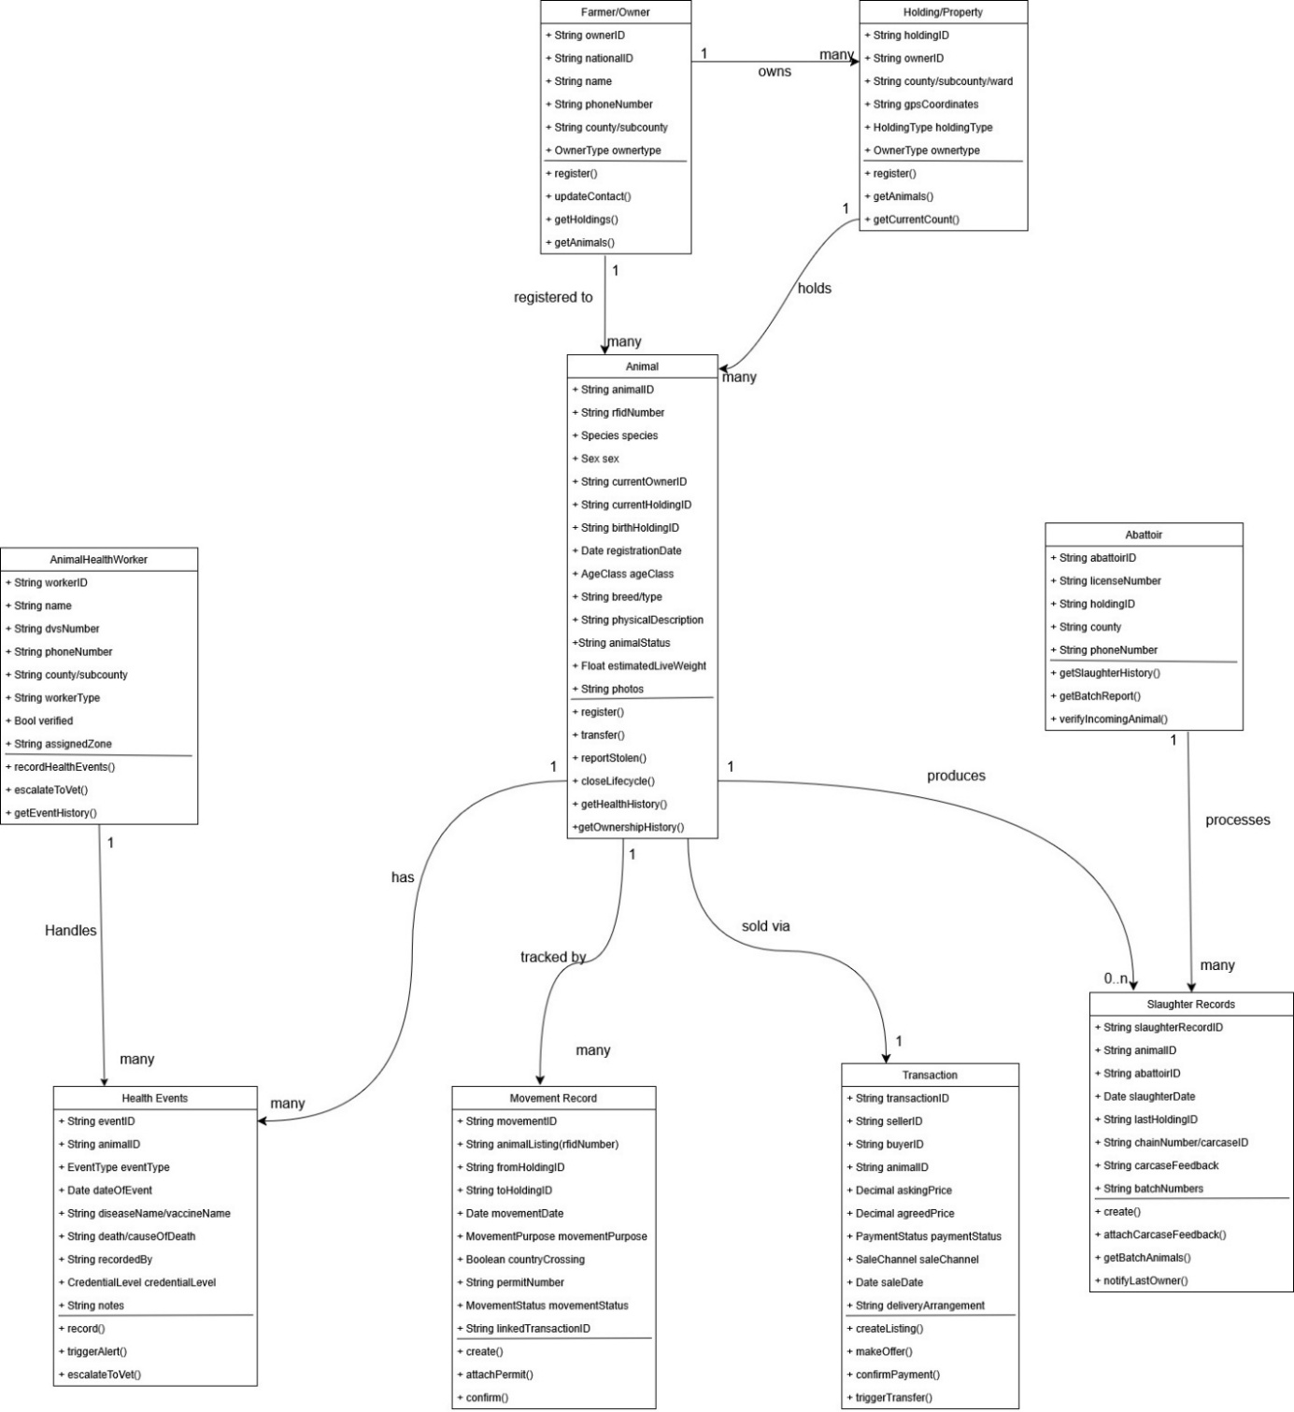
Figure 6: Class Diagram

4.3.6 Activity Diagram
An Activity Diagram illustrates the flow of control or object flow with a system, modeling the sequence of actions, decisions, and parallel processes. It is particularly useful for visualizing business processes and workflows.
The activity diagram for the platform models the primary lifecycle scenario: a farmer lists an animal, a buyer purchases it, makes a payment, the platform enforces cross-county permit compliance, ownership transfers atomically, and the animal is optionally processed at an abattoir with carcass feedback returned to the farmer.
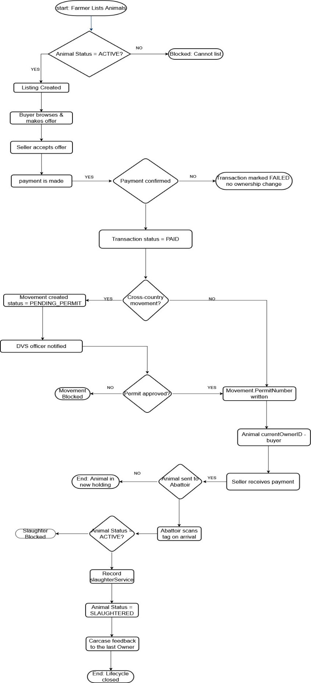
Figure 7: Activity Diagram

4.4 System Design
System design translates the analyzed requirements and models into a detailed architectural and component-level blueprint for the platform. Where system analysis focuses on what the system must do and how it must behave, system design addresses how it will be built: how the data will be physically stored, how the user interface will look and function, and how the components will be assembled.
This section presents three system design artefacts: the database schema, which specifies the physical tables, columns, data types, and constraints for the PostgreSQL relational database; the application wireframes, which define the key user interface screens for the mobile-first application; and the system architecture diagram.

4.4.1 Database schema
The database schema defines the organization of data as a blueprint of how the database is constructed. It specifies, for each table, the exact column names, data types, nullability constraints, primary keys (PK), foreign keys (FK), and unique constraints (UK). The schema is designed for PostgreSQL and follows the naming convention of snake_case for all table and column names.
The following diagram illustrates the relational database schema for the platform.

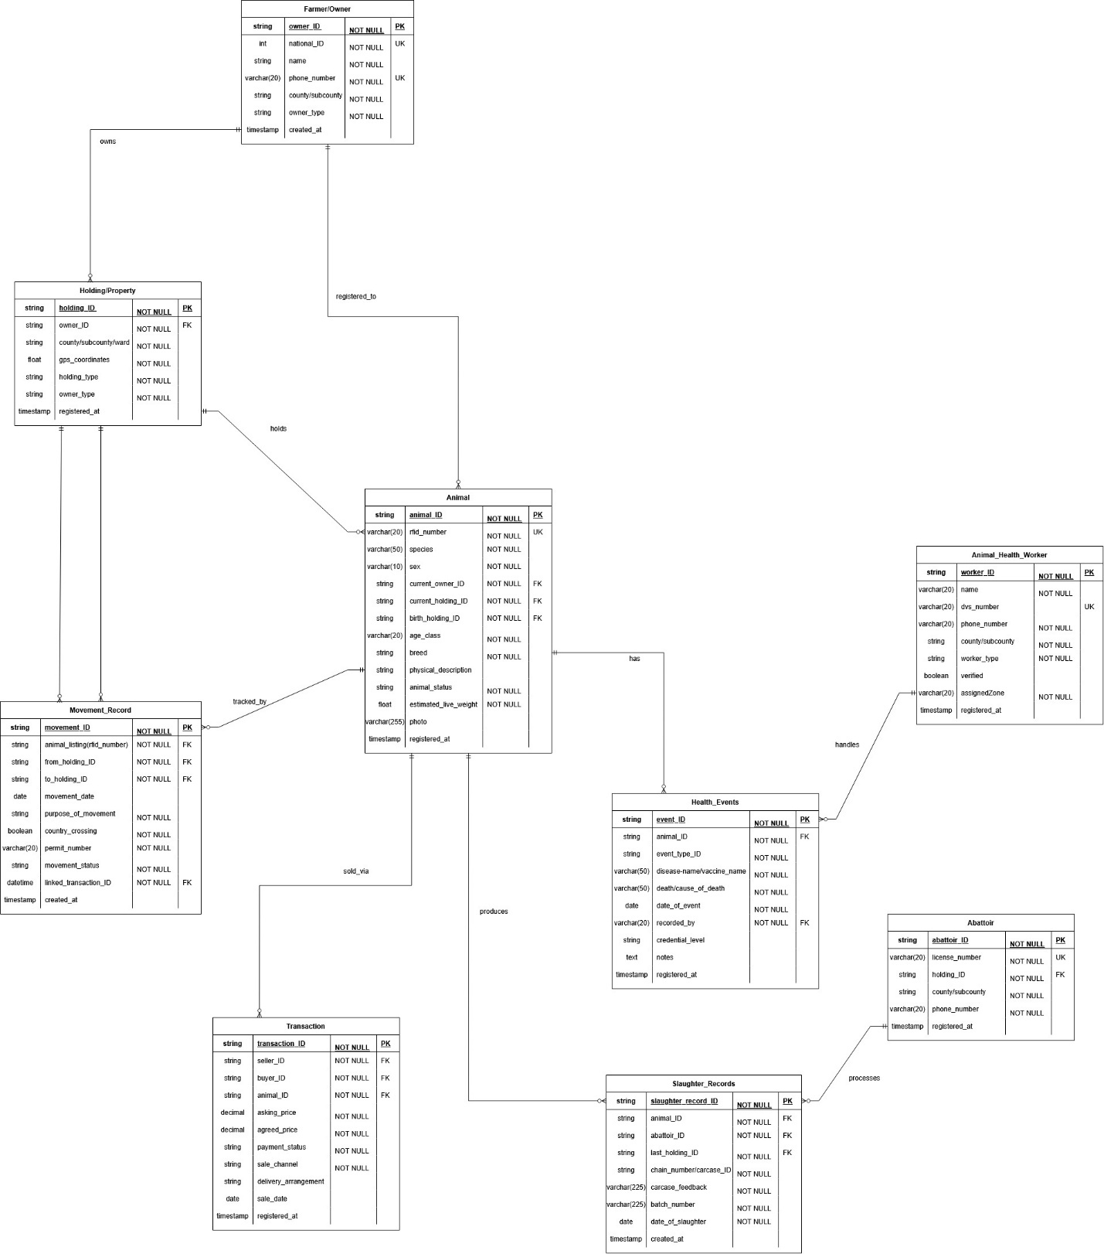

4.4.2 Wireframes
Wireframes provide a visual representation of the platform's user interface, focusing on layout, content, and functionality. They define the layout, navigation structure, and key interactive elements of each screen without specifying visual styling details such as color, typography, or photography. Wireframes are used to validate the user experience design with stakeholders before front-end development begins. Six wireframe screens are defined for the initial release, covering the core actor journeys.
These wireframes were selected based on frequency-of-use analysis of stakeholder workflows and represent the minimum viable interaction surfaces. Each screen corresponds to a high-frequency task identified through stakeholder engagement: farmers register animals and create listings daily, buyers browse the marketplace continuously, health workers record events at every farm visit, and abattoir operators must verify and record every slaughter. Prioritizing these six screens ensures that the most operationally critical journeys are validated with stakeholders before any front-end development begins, reducing the risk of costly redesign at a later stage:

- Home Dashboard — displays a summary of the farmer's registered herd, recent activity feed, active listings count, and quick-action buttons for the three most common tasks.

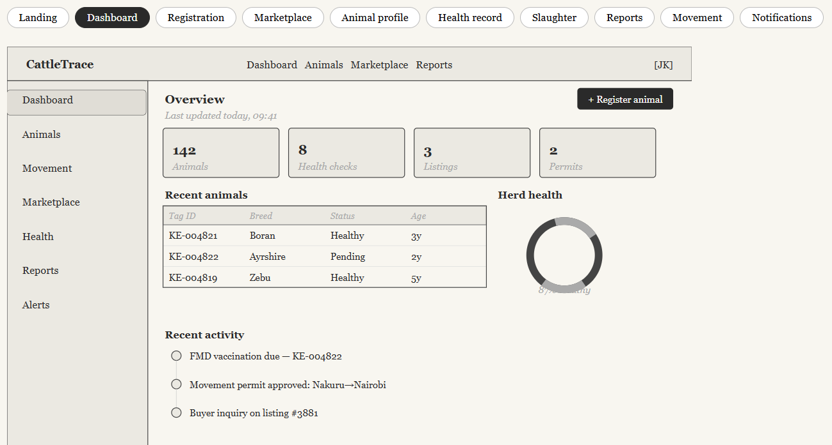

- Animal Registration — captures tag/RFID number (via scan or manual entry), species, sex, age class, breed, estimated weight, and allows photo upload.

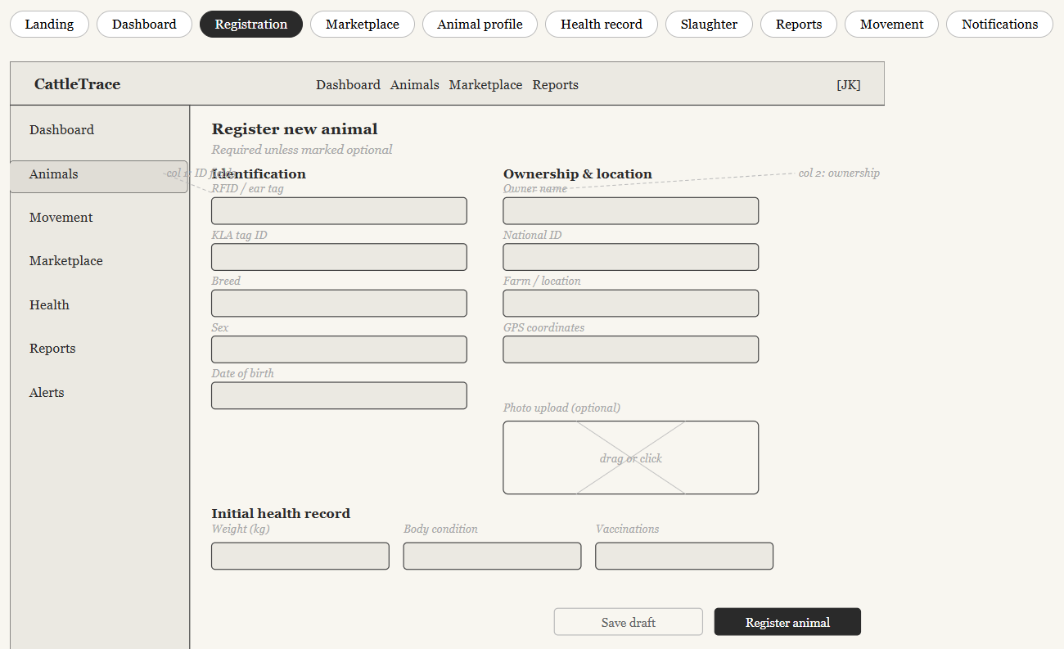

- Marketplace Listing — allows a seller to configure a listing from a registered active animal, setting price, sale type, and delivery arrangement.
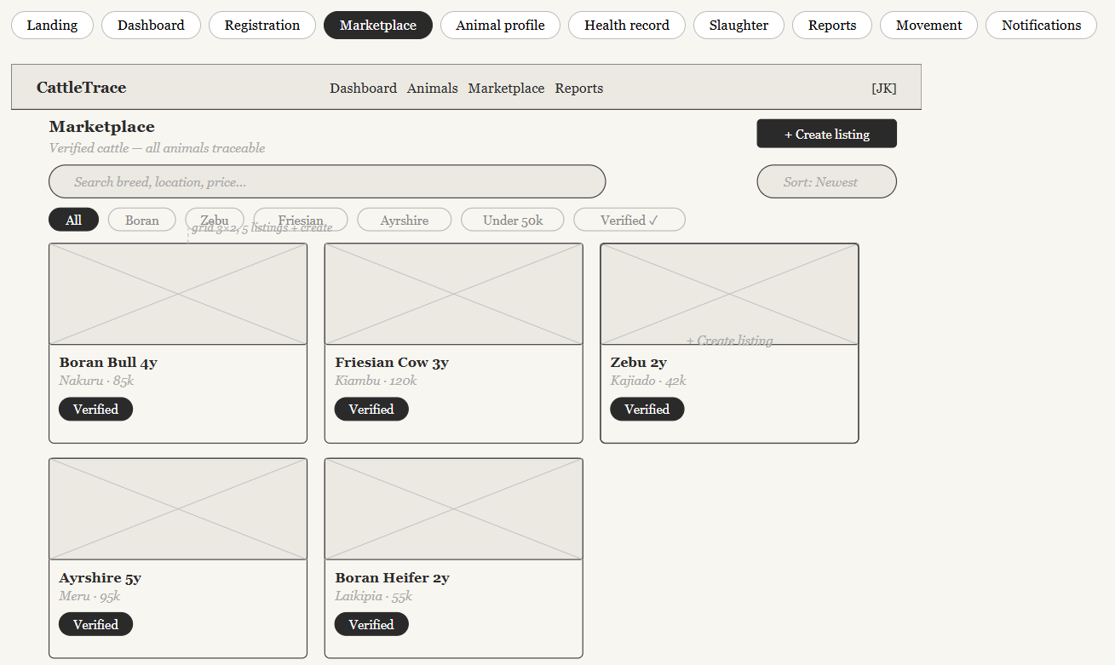

- Animal Profile — displays the complete record of a single animal including species details, health event history (with credibility indicators), ownership chain, and current status.
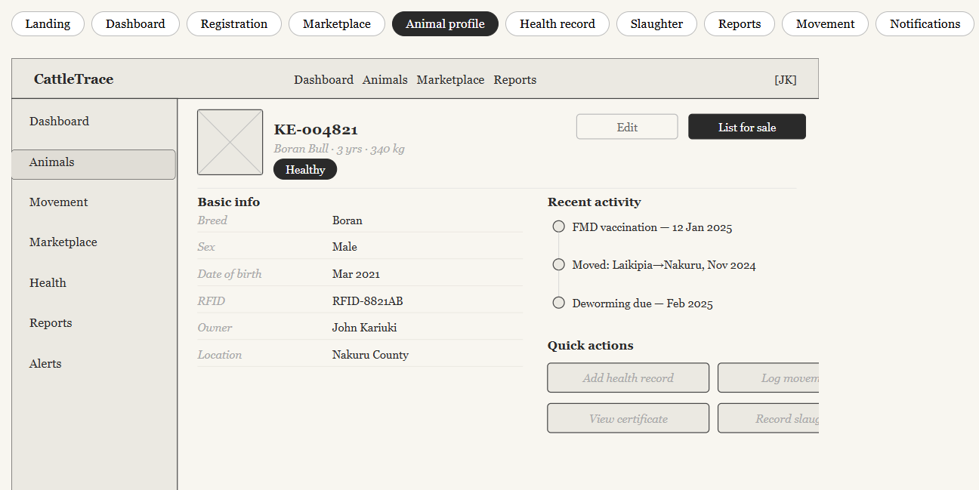

- Health Event Form — allows a vet or CAHW to record a vaccination or disease event, with a pre-submission warning when a notifiable disease is selected.
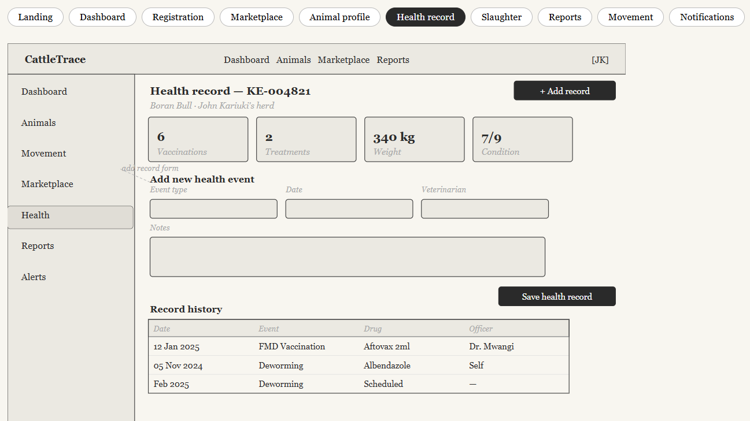
- Abattoir Slaughter event — allows the abattoir to verify the status of the animal before slaughter(ACTIVE, STOLEN, DEAD, or SLAUGHTERED), create a slaughter record and attach carcass feedback to the slaughter record.

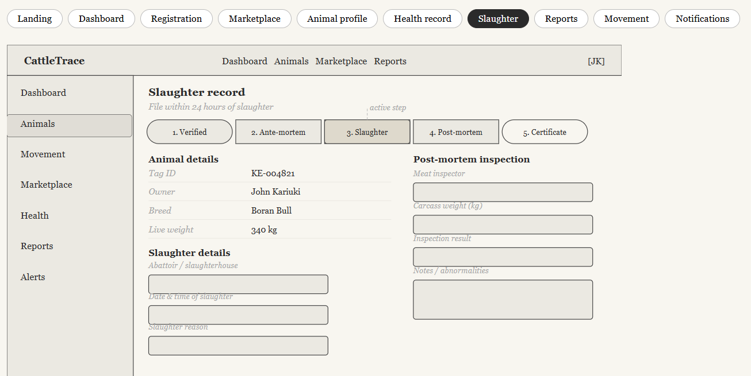

4.4.3 System Architecture
The system architecture defines the overall structure of the platform, including its components, their responsibilities, and how they interact. The proposed architecture is a multi-tiered, client-server model designed for scalability, reliability, and maintainability. It is organized into five distinct layers, each with clearly bounded responsibilities, plus a set of external service integrations.
Presentation Layer (React): This is the client-facing tier responsible for rendering the user interface and handling all direct user interactions. It is implemented as a responsive web application accessible from standard browsers on low-to-mid range devices common in Kenya’s agricultural sector. The presentation layer communicates exclusively with the Application Layer through RESTful API calls over HTTPS, and it never holds persistent application state beyond the current user session.
Application Layer (Django REST API): Built on the Django REST Framework, this layer exposes a versioned RESTful API that serializes and deserializes data between the presentation layer and the layers beneath it. It handles request routing, authentication (JWT token validation), authorization (role-based access control for Farmer, Vet, DVS Officer, Abattoir, and Admin roles), input validation, and response formatting. It acts as the single entry point for all client interactions and orchestrates calls to the Business Logic and Data layers.
Business Logic Layer: This layer encapsulates the core domain rules and workflows of the platform, implemented as Django service classes and model methods. It enforces constraints such as blocking the sale of animals whose status is STOLEN, DEAD, or SLAUGHTERED; triggering movement permit creation when a transaction crosses county boundaries; atomically updating ownership and movement records within a single database transaction; and escalating notifiable disease events to the county DVS officer. By centralizing these rules in a dedicated layer, the architecture ensures that business invariants cannot be bypassed regardless of which API endpoint is called.
Data Layer (PostgreSQL): The persistence tier is implemented using PostgreSQL, chosen for its reliability, support for complex relational constraints, and ACID-compliant transactions — essential for the atomic dual-write operations required by ownership transfers and slaughter records. Django’s ORM manages schema migrations and query construction, while raw SQL is used selectively for performance-critical reporting queries such as the county-level census and disease trace reports. All sensitive fields are encrypted at rest.
External Services: The platform integrates with three external systems through dedicated adapter modules in the Application Layer. The IPRS API (Integrated Population Registration Service) is called during farmer registration to verify national ID numbers against the government identity database, ensuring that only legitimate citizens can create accounts. The SMS Gateway is used to deliver asynchronous notifications — including movement permit approvals, offer responses, carcass feedback, and notifiable disease alerts — to users who may not have consistent internet access. RFID Integration is provided through a lightweight tag-reading interface that allows RFID scanner devices to submit tag numbers directly to the Animal Registration API endpoint, enabling hardware-assisted data capture at the farm or abattoir without requiring bespoke scanner software.

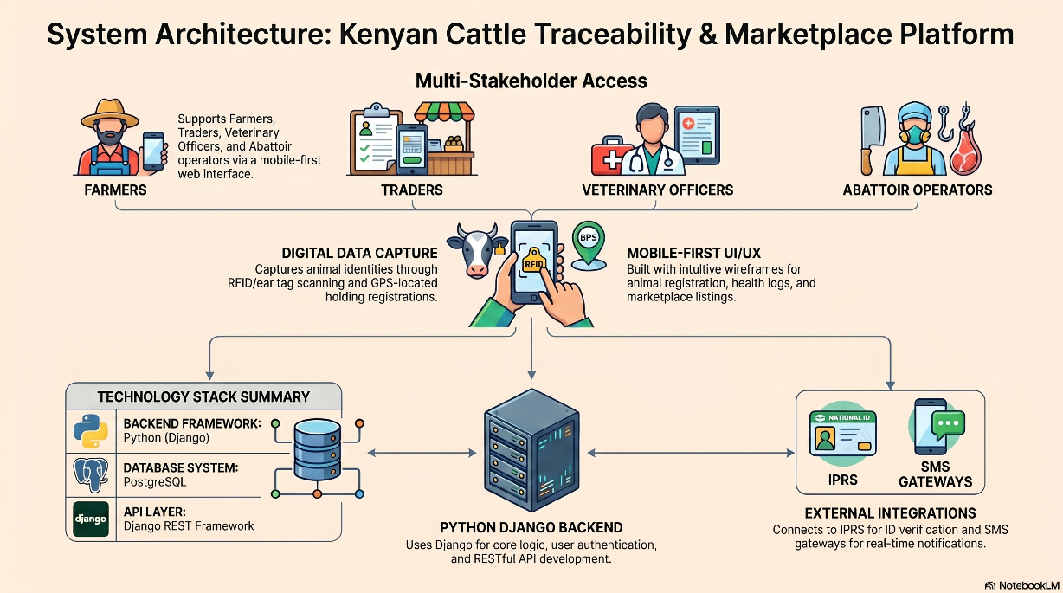

Chapter 5: System Implementation and Design

5.1 Introduction
This chapter presents a comprehensive account of the implementation and testing phases of the platform — a web-based cattle traceability and marketplace system designed to support livestock registration, health monitoring, movement tracking, and verified trade in Kenya's agricultural sector.
The implementation phase translated the system design artefacts developed in the preceding chapters — including use case diagrams, entity-relationship models, and UI wireframes — into a fully functional web application. Each system module was developed iteratively, with continuous reference to the functional and non-functional requirements established in Chapter 2. The implementation followed a modular architecture, ensuring that individual components such as animal registration, health records, movement tracking, and the marketplace could be developed, tested, and deployed independently.
The testing phase was conducted to validate that the implemented system meets its specified requirements, behaves correctly under both normal and adverse conditions, and is robust against common security vulnerabilities. A multi-paradigm testing strategy was adopted to achieve comprehensive coverage across all system modules.

5.2 Description of the Implementation Environment
The implementation environment encompasses the hardware infrastructure and software stack used during the development of the platform. The environment was selected to balance development efficiency, scalability, and compatibility with the target context of a web application accessible from low-to-mid range devices common in Kenya's agricultural sector.

5.3 Hardware Requirements and Specifications
The following hardware specifications were used for the development and local testing environment. Production deployment targets a cloud server meeting the server-side minimum specifications.

Development Machine
Component | Specification
Processor | Intel Core i7-11th Gen, 2.8 GHz (8 cores)
RAM | 16 GB DDR4
Storage | 512 GB NVMe SSD
Operating System | Windows 11
Network | Wi-Fi 802.11ac and Ethernet (100 Mbps)

5.4 Software Requirements
The software stack is divided into client-side (front-end) and server-side (back-end) requirements.

5.4.1 Client-Side Requirements
The client-side application runs in any modern web browser. The following table summarizes the software and browser requirements for end users.

Component | Requirement / Version
Web Browser | Google Chrome, Mozilla Firefox 110+, Microsoft Edge 110+, or Safari 16+
Internet Connection | Minimum 1 Mbps for standard use; 5 Mbps recommended for image-heavy pages
PDF Reader | Required for viewing slaughter certificates and reports (Adobe Reader or browser built-in)

5.4.2 Server-Side Requirements
The server-side application is built on a Node.js runtime with a PostgreSQL relational database. The following software components are required on the server.

Component | Version / Specification
Database Management System | PostgreSQL 17
Backend Framework | Python with Django
Version Control | Git
Other Libraries | Django Rest Framework for API development, Postman for testing the APIs

5.5 Dataset Description
The platform processes a diverse range of data critical for cattle traceability and marketplace functionalities. The dataset primarily includes:
Dataset Components | Description
Animal Identification Data | Unique animal IDs, breed, age, weight, RFID numbers (if applicable), physical descriptions, and photographs.
Ownership Records | Farmer/owner details, transfer history, and registration dates.
Health and Veterinary Records | Vaccination history, disease incidents, treatment logs, veterinary officer certifications, and health status.
Marketplace Listings | Cattle for sale (with associated traceability data), pricing, location, seller contact information, and transaction history.
User Data | Authentication credentials, roles (farmer, veterinarian, buyer, administrator), contact information, and activity logs.

This data is structured and stored within the PostgreSQL database, ensuring data integrity, security, and efficient retrieval for various system operations and analytics.

5.6 System Implementation [System Modules]
The system is modularly designed, with each module addressing specific functional requirements. The core modules implemented are:

5.6.1 Animal Registration and Identification Module
This module facilitates the unique identification and registration of individual cattle. It allows farmers to input detailed information about each animal, including its unique ID, breed, age, weight, and upload photographs. The module integrates with the backend to store this data securely in the PostgreSQL database, ensuring each animal has a verifiable digital identity. The frontend, built with React and TypeScript, provides an intuitive user interface for data entry and viewing.

5.6.2 User Management Module
This module handles user authentication, authorization, and profile management. It supports different user roles (farmers, veterinarians, buyers, administrators) with varying levels of access and permissions. Django's built-in authentication system is utilized for secure login and session management, while custom logic in Python extends role-based access control. The React frontend provides user registration, login, and profile editing interfaces.

5.6.3 Health and Veterinary Records Module
This module enables the recording and management of health-related data for each animal. Veterinarians can log vaccinations, treatments, disease diagnoses, and certify the health status of cattle. This critical information is linked to the animal's unique ID, providing a comprehensive health history. The module also incorporates the multi-stakeholder authentication feature, allowing certified veterinary officers to digitally sign off on health data, enhancing data credibility. The frontend provides forms for veterinarians to input data and view animal health records.

5.6.4 Analytics Module
This module is responsible for processing and visualizing data related to cattle populations, health trends, and market activities. While the initial scope might focus on basic reporting, the Python backend can be extended to integrate with data analysis libraries to generate insights. The frontend would display dashboards and reports, providing valuable information to stakeholders. (Note: The current documentation does not detail specific analytics features, so this section will be general).

5.6.5 Livestock Marketplace Module
This module connects cattle sellers (farmers) directly with buyers. Farmers can create digital listings for their cattle, including photos, detailed descriptions, and health information pulled from the traceability system. Buyers can browse listings, filter by various criteria, and initiate transactions. The Django backend manages listings, buyer-seller interactions, and transaction records, while the React frontend provides a dynamic and responsive marketplace interface.

5.7 System Testing
System testing was conducted to ensure the platform meets its functional and non-functional requirements, identifying and rectifying defects before deployment. A combination of testing paradigms was employed to cover various aspects of the system's quality.

5.7.1 Testing Paradigm

- White Box Testing
White box testing (also known as structural or glass box testing) was applied to the server-side codebase, focused on the internal structure and workings of the code. This involved unit testing of individual functions and components, particularly in the Python (Django) backend, to ensure logic correctness and code coverage.

- Black Box Testing
Black box testing was applied to evaluate the system's functionality from an external perspective, without knowledge of its internal implementation details. This included testing user interfaces, workflows, and system responses against specified requirements. Test cases covered all primary modules.

- Penetration Testing (Pentest)
Penetration testing (pentesting) was conducted to identify security vulnerabilities within the application and infrastructure. This involved simulating attacks to uncover weaknesses that could be exploited by malicious actors. The test scope included the web application interface, REST API endpoints, authentication mechanisms, and session management. Specific tests targeted SQL injection, cross-site scripting (XSS), insecure direct object reference (IDOR), and unauthenticated API access. The tests were done manually.

- Unit Testing
Unit testing was performed at the earliest stages of development, focusing on testing individual units or components of the software in isolation. For this project, unit tests were written for critical backend functions(such as token generation and date validation) and frontend components.

5.7.2 Testing Results
The following tables present the testing results for the key system modules. Test cases are organized by module.

Table 5.1: Authentication & Access Control
Test Case | Description | Test Data | Expected Outcome | Actual Result | Verdict
TC-AUTH-01 | Login with valid credentials | Email: farmer@gmail.com, Password: ValidPass@123 | User authenticated; redirected to dashboard | Login successful; dashboard loaded with correct user context | Pass
TC-AUTH-02 | Login with incorrect password | Email: farmer@gmail.com, Password: WrongPass | Error: 'Invalid email or password' | Login rejected with a generic error message | Pass
TC-AUTH-03 | Access dashboard without authentication | Unauthenticated GET /dashboard | Redirect to login page with 401 response | Unauthenticated request redirected to login page | Pass

Table 5.2: Animal Registration Module
Test Case | Description | Test Data | Expected Outcome | Actual Result | Verdict
TC-REG-01 | Register animal with valid data | Tag: KE-001, Breed: Boran, Owner: John Kariuki, DOB: 01/03/2021 | Animal saved; profile accessible with correct details | Animal registered successfully; profile page populated correctly | Pass
TC-REG-02 | Register with duplicate tag ID | Tag: KE-001 (already existing) | Error message: 'Tag ID already registered' | System returned validation error preventing duplicate entry | Pass
TC-REG-03 | Register without mandatory fields (Owner field empty) | Tag: KE-004, Breed: Zebu, Owner: (empty) | Form rejects submission; highlights missing required field | Form highlighted Owner field; submission blocked | Pass
TC-REG-04 | Register with invalid date format | DOB: 99/99/9999 | Validation error: 'Invalid date' | System rejected invalid date and displayed error message | Pass
TC-REG-05 | Upload photo exceeding size limit | Image file: 15MB JPEG | Error: 'File exceeds 5MB limit' | Upload rejected with appropriate error message displayed | Pass

Table 5.3: Health Record Module
Test Case | Description | Test Data | Expected Outcome | Actual Result | Verdict
TC-HLT-01 | Add vaccination record to existing animal | Animal: KE-001, Event: FMD Vaccination, Drug: Aftovax, Date: 12/01/2025, Vet: Dr. Mwangi | Record saved and visible in health history table | Vaccination record saved and reflected in health history | Pass
TC-HLT-02 | Add health record without specifying event type | All fields filled except Event Type | Form rejects submission; event type is required | Form blocked submission and highlighted event type field | Pass
TC-HLT-03 | Schedule upcoming vaccination reminder | Event: Deworming, Date: 01/03/2025 (future date) | Record saved with 'Upcoming' status; reminder triggered | Record created with Upcoming badge; notification scheduled | Pass
TC-HLT-04 | View complete health record history for animal | Animal: KE-001 with 6 prior records | All 6 records displayed in chronological order | All records displayed correctly with dates and officer names | Pass
TC-HLT-05 | Edit an existing health record | Modify dosage on TC-HLT-01 record from 2ml to 3ml | Updated value saved; audit trail updated | Record updated; change logged in audit trail | Pass

Table 5.4: Marketplace Module
Test Case | Description | Test Data | Expected Outcome | Actual Result | Verdict
TC-MKT-01 | Create a new marketplace listing | Animal: KE-001, Price: KES 85,000, Description: Healthy Boran bull | Listing published and visible on marketplace | Listing created and displayed in marketplace grid | Pass
TC-MKT-02 | Search for animals by breed and location | Query: Breed=Boran, Location=Nakuru | Filtered results showing only Boran cattle from Nakuru | Results correctly filtered to matching listings only | Pass
TC-MKT-03 | Send buyer inquiry on listing | Listing #3881, Message from buyer Grace Wanjiku | Message delivered to seller; seller notified | Inquiry delivered; seller received notification | Pass
TC-MKT-04 | List an animal with incomplete traceability record | Animal: KE-020 (no health records entered) | Warning shown; listing created but flagged as unverified | Warning displayed; listing published with 'Unverified' badge | Pass
TC-MKT-05 | Remove a marketplace listing | Listing #3881 by owner John Kariuki | Listing removed from public marketplace | Listing removed; no longer visible to other users | Pass

Chapter 6: Conclusion, Recommendations, and Future Works

6.1 Conclusions
The Web-based Cattle Traceability Platform successfully addresses the critical need for enhanced transparency and efficiency within Kenyan Livestock sector. By integrating unique animal identification, health record management, and a marketplace, the platform provides a robust digital solution to long-standing. The implementation, utilizing Python (Django) for the backend and React & TypeScript for the frontend, demonstrates the feasibility of developing a scalable and maintainable system capable of handling data-intensive workloads and supporting multi-stakeholder interactions. The modular design, encompassing Animal Registration, User Management, Health and Veterinary Records, and Livestock Marketplace modules, ensures a structured approach to system development and facilitates future enhancements. Through testing, the platform has proven to be functional, reliable, and capable of meeting its defined objectives.

6.2 Recommendations
Based on the development of the platform, the following recommendations are put forth to further enhance its utility, adoption, and impact:

6.2.1 Enhanced Security Measures
Continuously review and enhance security protocols, including regular penetration testing and security audits, to protect sensitive animal and user data from potential cyber threats.

6.2.2 Offline Capabilities
Given the limitations of internet connectivity in some rural areas of Kenya, investigate and develop offline functionalities for critical data entry, with subsequent synchronization when connectivity is restored. This would significantly enhance the platform's accessibility and usability in remote regions.

6.2.3 Phased Rollout
Implement the platform through a phased approach, starting with pilot regions, to allow for interactive feedback and refinement.

6.3 Future Works
The current platform lays a strong foundation for a comprehensive Livestock management ecosystem. Future enhancements could include:

6.3.1 Advanced Analytics and Reporting
Develop more sophisticated analytics tools to provide deeper insights into livestock population dynamics, disease outbreak patterns, market trends, and economic impacts. This could involve integrating machine learning models for predictive analytics on disease spread or market price fluctuations.

6.3.2 Mobile Application Development
Create native mobile applications for Android and iOS to provide a more tailored and accessible experience for farmers and veterinarians, especially those operating in the field. This would complement the web-based platform and leverage mobile device capabilities such as GPS maps for location tracking.

6.3.3 Integration of IoT and RFID Technology
While acknowledged as a limitation in the current scope, future work should prioritize the integration of RFID tags and other IoT devices for automated animal identification and real-time data collection. This would significantly improve the accuracy and efficiency of traceability.

6.3.4 Financial Services Integration
Explore partnerships with financial institutions to integrate payment gateways and microfinance options directly into the marketplace, facilitating smoother transactions and providing financial support to livestock producers.

6.3.5 Blockchain Technology for Enhanced Traceability
Investigate the feasibility of incorporating blockchain technology to provide an immutable and transparent record of animal movements, health interventions, and ownership transfers, thereby further bolstering trust and security in the traceability system.

References
Africa Check. (2024). How much does livestock contribute to Kenya’s Gross Domestic Product (GDP)?
Assis, N. R., & Batista, B. G. (2024). eCattle: A Platform for Traceability and Management of Livestock Transactions Using Smart Contracts. 15th International Conference on Information, Intelligencem Systems & Applications (IISA), 1-9.
Australian Government. (2016). Agrucultural Competitiveness White Paper. Retrieved from https://www.agriculture.gov.au/sites/default/files/documents/ag-competitiveness-white-paper_0.pdf
Bernard Bet, F. M. (2015). Piloting livestock identification and traceability systems in pastoral production systems in eastern Africa. Nairobi, Kenya: International Livestck Research Institute.
Brocke, J. V., Hevner, A., & Maedche, A. (2020). Introduction to Design Science Research. In Design Science Research (pp. 1-13). doi:10.1007/978-3-030-46781-4_1
Calitz, P. A. (2016). Framework for a voluntary traceability system for beef. 1-171.
FAO. (2020). The role of digital technologies in livestock traceability and trade. FAO Markets and Trade. Retrieved from https://openknowledge.fao.org/server/api/core/bitstreams/88ccddac-cc47-459c-96dd-3a9047e9fddb/content
geeksforgeeks. (2026). Object-Oriented Analysis and Design (OOAD). Software Engineering. Retrieved from https://www.geeksforgeeks.org/software-engineering/object-oriented-analysis-and-design/
iCow. (n.d.). Retrieved from https://icow.co.ke/
ID Tech Solutions Private Limited. (n.d.). RFID Animal Tracking & Identification: How it works. Retrieved from https://www.idsolutionsindia.com/applications/livestock-tracking/
Jaguza Farm. (n.d.). Retrieved from https://jaguzafarm.com/
LITS-SA. (n.d.). Retrieved from https://lits.csir.co.za/
LITS-SA. (n.d.). LITS-SA - A Farmer-Led Livestock Traceability Initiative. Retrieved from https://lits-sa.com/
Mdoda, L., & Mdiya, L. (2022). Factors affecting the using information and communication technologies (ICTs) by livestock farmers in the Eastern Cape province. Cogent Social Sciences. Retrieved from Cogent Social Sciences
Mihindo, D. N., Juster, K., Maina, A., Manduna, C., & Hansen-Kuhn, K. (August 2025). KENYA LIVESTOCK SECTOR: Value Chain Analysis, Trade Impacts & Recent Trends. Institute for Agriculture & Trade Policy(IATP); Biodoversity and Biodiversity Association of Kenya(BIBA-K); Mihindo, Dr. Nehemiah. Retrieved from https://www.iatp.org/kenya-livestock-sector
Ministry of Agriculture and Livestock Development. (2026). Animal Identification and traceability Strategy(ANITRAC). 1-27. Retrieved from https://kilimo.go.ke/wp-content/uploads/2024/08/LITS-Strategy-Final-Draft.pdf
Mokgetse, T. L. (2026, March). Advances in animal traceability systems: A systematic review of technologies, benefits, and challenges. (D. B. Gyampoh, Ed.) Scientific African, 31, 1-15. Retrieved from https://www.sciencedirect.com/science/article/pii/S2468227625005861#fig0002
Mutua, E., Bukachi, S., Bett, B., Estambale, B., & Nyamongo, I. (May 2017). Youth Participation in Smallholder Livestock Production and Marketing. In I. Bulletin, S. Ayele, S. Khan, & J. Sumberg (Eds.), Africa's Youth employment Challenges: New Perspectives (Vol. 48, pp. 95-108). Institute of development Studies.
NamLITS Online. (n.d.). Retrieved from http://www.namlits.com/web/litwhome.p
NLIS. (n.d.). Retrieved from https://www.nlis.com.au/
NLIS. (n.d.). National Livestock Identification System (NLIS). Retrieved from https://www.integritysystems.com.au/identification--traceability/national-livestock-identification-system/
Paskin, R. (n.d.). Livestock identification and recording: The Namibian experience. Retrieved from https://www.icar.org/Documents/technical_series/ICAR-Technical-Series-no-9-Sousse/Paskin.pdf
Schmidhuber, M. T. (2020). Optimising traceability in trade for live animals and animal products with digital technologies. 235-244.
Schwaber, K., & Sutherland, J. (2017). The Definitive guide to Scrum: The Rules of the Game. The Scrum Guide, 1-19. Retrieved from https://scrumguides.org/docs/scrumguide/v2017/2017-Scrum-Guide-US.pdf
Sirak Bahta, F. W. (2023). CURRENT STATE AND PROJECTIONS FOR THE FUTURE. In LIVESTOCK SECTOR TRANSFORMATION IN KENYA (pp. 51-80).
Sommerville, I. (2011). Software Engineering (9th ed.). Pearson Education.
Tshepiso Larona Mokgetse, H. H. (2026). Advances in animal traceability systems: A systematic review of technologies, benefits, and challenges. Scientific African, 1-15.
World Bank. (2024). Agricultural Innovation and Technology in World Bank Projects. 1-15. Retrieved from https://openknowledge.worldbank.org/server/api/core/bitstreams/30b7185a-6131-48d5-b79e-de3c6c00c582/content
World Bank Group. (2025). Digital Agriculture Roadmap Playbook. Retrieved from https://documents1.worldbank.org/curated/en/099053025063021993/pdf/P508004-f943a09b-c45f-4c93-b554-9dd1decd1e7c.pdf

Appendix
Appendix 1: Gantt Chart
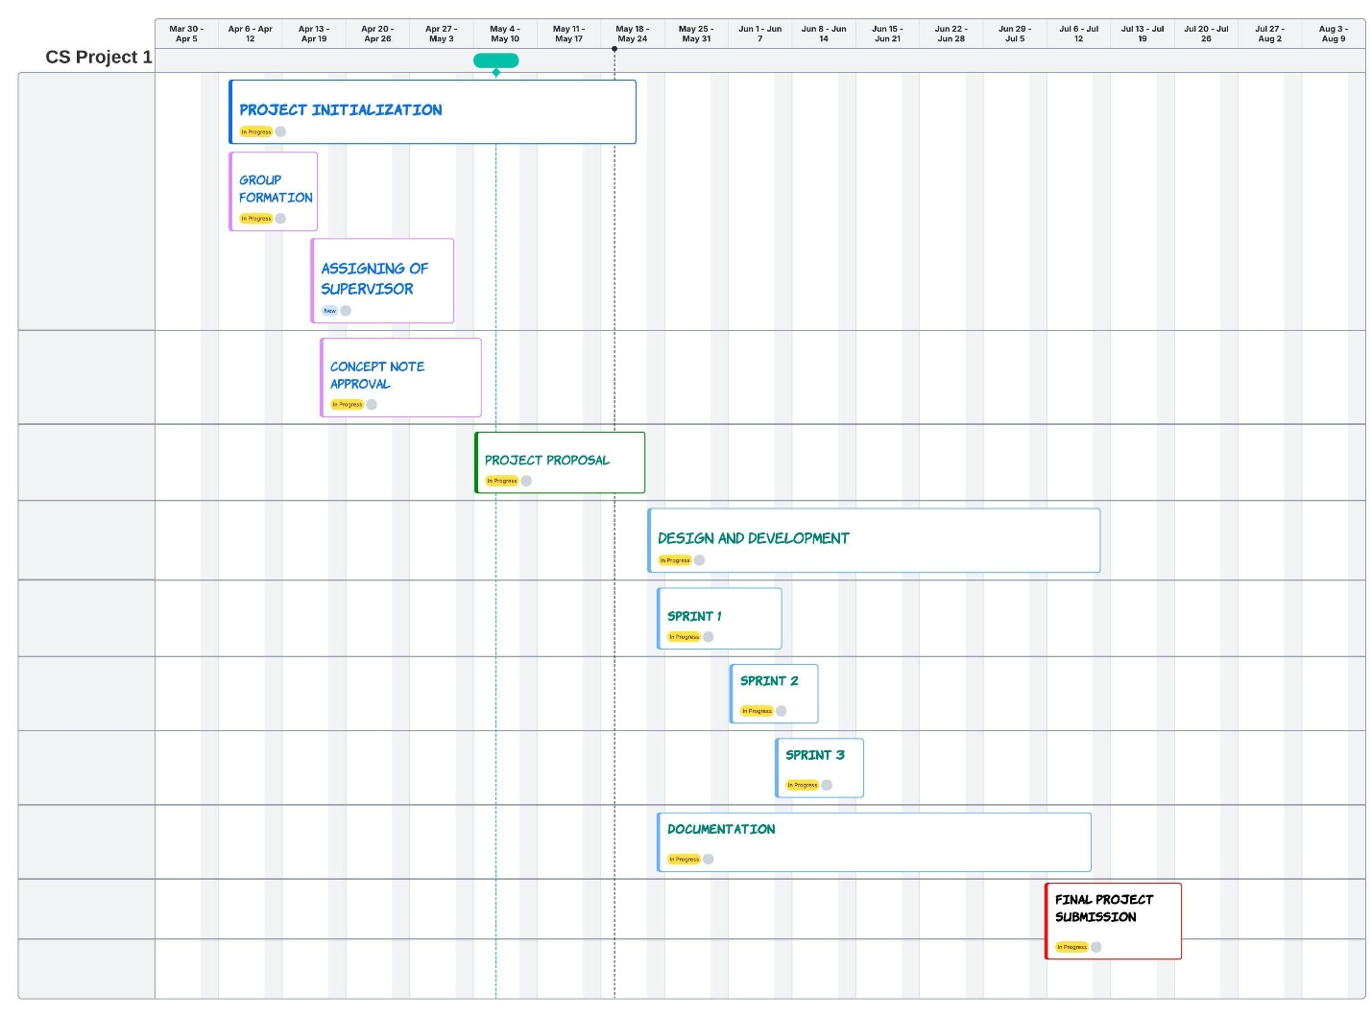
Appendix 8: Gantt Chart

